## 

## 

# MSc Project Report 2024-2025

**Early Signals and Surveillance Challenges in Filovirus Outbreaks**

Candidate Number: 492518

Word Count: 10,110

Project Length: Standard

Submitted in part fulfilment of the requirements for the degree of MSc Control of Infectious Diseases September 2025

MSc Project Report 2024-2025 0

Acknowledgements 4

Abstract 6

Abbreviations List 7

Introduction 8

Aims and Objectives 13

Methods 14

Study Type 14

Information Sources and Search Strategy 14

Literature Eligibility Criteria 16

Inclusion Criteria 16

Exclusion Criteria 16

Study Selection 17

Source Credibility 17

Data Extraction 17

Quantitative Analysis 18

Software Usage 18

Statistical Analysis 18

Visualizations 19

Narrative Analysis 19

Ethics 19

Results 20

Literature Search 20

Report Source 28

Index Cases 29

Diagnosis and Nosocomial Effects 30

Outbreak Report to Declaration 32

One Health 35

Discussion 36

Setting the Scene 36

Elusive First Signals 37

Clinician Reporting 38

Hospitals and Laboratory Capacity 40

Community Engagement 42

One Health Surveillance 43

System Learning and Future Preparedness 45

Limitations 46

Recommendations 47

References 49

Appendix 57

Appendix A: PRISMA 2020 Checklist 57

Appendix B: Search Strategies 62

Appendix C: Extraction Form 66

Appendix D: Code 67

Appendix E: Bibliography 81

Appendix F: Index Case Sex 93

Appendix G: Figure 8 Extended 93

Appendix H: One Health Messaging 94

Student’s Questionnaire 95

## 

## Acknowledgements

**Project Development**

I would first like to thank my external and main advisor, Dr. Daniel Bausch, for taking me on as a student to complete my summer project. Dr. Bausch encouraged me to ask Dr. David Heymann to be my internal advisor. Their support and knowledge were invaluable in developing this project. Through discussions with Dr. Bausch, we identified areas of mutual interest and he suggested an idea for a project that allowed us to develop both concept and scope in collaboration. The study design incorporated his suggestions, while I defined the overall study framework, inclusion/exclusion criteria, literature search strategy, data extraction template, and data analysis structures.

**Contact, Input, and Support**

I am incredibly thankful to have been able to meet Dr. Bausch several times in person over the course of the project to discuss my progression, as well as to have had electronic exchanges when clarification was necessary. I also wish to thank Dr. Heymann for making time to meet with me, and for his feedback and guidance on project structure during that time.

**Main Research Work**

The core of this research work including literature search, screening, and data extraction and analysis was wholly undertaken by myself. I wish to thank the LSHTM library team for their aid in developing the search strategy, especially for a non-standard review process. I would also like to thank my supervisor for providing key background literature before developing the project as well as helping me track down one hard-to-find outbreak report. His advice was crucial in the development of my recommendations, and I greatly appreciate and admire his prioritization of real-world applications born from his field and career experiences.

**Writing-up**

Dr. Bausch read and advised on an intermediate draft of this report as well as when it was in progress. His advice on figure accuracy, structure, and wording was invaluable and provided clarity to my report, strengthening the final presentation.

**Practical Assistance**

I would like to thank my parents for putting their editorial and proofreading skills to use on this article.

**AI Assistance**

I wish to acknowledge the assistance of the Gemini 2.5 Flash (Thinking) model in drafting and debugging R code for analysis, providing limited advice on structure for selected essay sections (Introduction, Methods, Discussion), and offering editorial suggestions to enhance readability and conciseness.

**Personal Acknowledgements**

Primarily, gratitude to my family for their constant support of my education and international experiences, I promise to use all you have given me for good. Thank you to my partner who encouraged me through the statistical analysis and coding portions of the project and who occasionally cooked me dinner. Lastly, a tremendous thanks to my CID cohort— people that I did not know a year ago but who will be colleagues and friends long into the future. I cannot imagine a better group of humans to have experienced this year and project period with. Thank you for laughs, destressing stress-sessions, and many, many happy days.

## Abstract

Emerging zoonotic viruses pose significant global health concerns, especially those with high fatality rates, such as the filoviruses Ebola and Marburg. Robust surveillance for rapid detection of highly pathogenic viruses is critical for pandemic preparedness and outbreak control. We undertook an integrative literature review to investigate patterns around early outbreak signals and detection of filoviruses. We systematically reviewed 46 community-based filovirus outbreaks (1976 to 2025), identifying 99 relevant articles through five electronic databases and grey literature and, through quantitative analysis and narrative synthesis, explored the signals of these outbreaks in their early stages, from the first alert to official outbreak declaration. The majority (87%) of outbreak alerts originated from clinicians/hospital staff, a proportion that has remained unchanged over time and indicates the continued predominance of event-based surveillance. Primary alerts due to single cases (63%) occurred more often than case clusters (37%), though this difference was not statistically significant. There was no difference in this categorization regarding time from first putative case(s) or clusters to outbreak declaration (p>0.5). Healthcare worker infections, reported in 76.7% of outbreaks, were weakly associated with longer declaration times (median 15 vs 6 days, p=0.07). Still, time to official outbreak declaration has decreased (p=0.03), reflecting improvements in overall filovirus surveillance.

Our review reveals that the first signals of filovirus outbreaks most often arise from frontline clinicians and event-based surveillance. We offer recommendations for strengthening clinical suspicion of filoviruses, increasing preparedness, and integrating new/underutilized technologies for surveillance, including from a One Health surveillance perspective.

## 

## Abbreviations List

BDBV - Bundibugyo ebolavirus

BVD - Bundibugyo ebolavirus disease

CDC - Centers for Disease Control and Prevention

CFR - Case-fatality ratio

EBOV - Zaire ebolavirus

EBS - Event-based surveillance

EVD - Zaire ebolavirus disease

HCW - Healthcare worker

IBS - Indicator-based surveillance

IPC - Infection prevention and control

MARV - Marburg virus

MVD - Marburg virus disease

N/A - Not applicable

NR - Not reported

POC - Point of care

PPV - Positive predictive value

PRISMA - Preferred Reporting Items for Systematic Reviews and Meta-Analyses

SDV - Sudan ebolavirus disease

SUDV - Sudan ebolavirus

VHF - Viral haemorrhagic fever

WHO - World Health Organization

## 

## 

## 

## Introduction

Over the past thirty years, of the thirty new human pathogens that have emerged, a striking 75% have originated in animals.1 Scientific consensus is that the looming spectre of Disease X, a currently unknown pathogen with potential for catastrophic human disease at international scales, is highly likely to be a virus with zoonotic origins.2 The risk posed by zoonotic viruses, both emerging and re-emerging, is accelerating due to unprecedented processes of global change.3 Human land use shifts, including deforestation and changing agricultural practices increase the interface between human populations and wildlife and create increased opportunity for pathogen spillover. Climatic change constantly alters vector and host/reservoir species distributions and general disease ecology, expanding ranges of potential infection and disease emergence. Furthermore, intensified globalization, shipping and sales of goods including live animals, and human migration due to climate change and political factors have facilitated the rapid emergence of novel viral threats. These may quickly become international concerns— from Dengue to SARS to Ebola— especially if emerging in new, unexpected locations. The consequences of these outbreaks often grow outside of the realm of strictly planetary and human health to economics and even social and political stability.

Among these zoonotic threats, viruses of the family *Filoviridae*,which cause viral haemorrhagic fevers (VHFs) in primates, including humans, are cited on the WHO’s list of priority pathogens. This group includes the two well-known VHFs: Ebola virus and Marburg virus, both with links to zoonotic spillover events. While Marburg virus has a reservoir in fruit bats (specifically, the Egyptian rousette bat, *Rousettus aegypticacus*)4, the natural reservoir of Ebola viruses has not yet been discovered— though bats are also heavily suspected.5 What is known, however, is that these viruses spill over into human populations via direct human contact with natural reservoirs or through intermediate animal hosts such as non-human primates. Once in the human population, the viruses transmit primarily through contact with the body fluids of someone who is actively infected or recently diseased from the disease. Initial disease symptoms are notoriously non-specific, complicating clinical diagnosis and slowing outbreak reporting, especially in many filovirus outbreak areas where other fever-prone diseases (such as malaria) are endemic.6

While these viruses only emerge sporadically, they are clinically severe; the diseases caused by both viruses have high case fatality ratios (CFR), over 90% in certain settings, making them among the deadliest for humans.7 Additionally, as seen in the West Africa Ebola outbreak of 2013-2016, filovirus outbreaks usually mobilize extensive international involvement and collaboration driven by the fear of cross-border spread and concerns of threats to global health security. This, coupled with their unique epidemiological characteristics and persistent challenges surrounding surveillance and early detection for outbreaks, makes filoviruses a critical focus for understanding how to build resilient surveillance and outbreak detection systems— knowledge which may be transferable to response for high-consequence pathogen emergence.

Historically, both Ebola and Marburg virus are diseases associated with Sub-Saharan Africa, and often with remote and underserved health and social care areas. Marburg virus was first discovered in 1967 via accidental introduction from grivets (a type of monkey native to east Africa) to laboratory staff in Marburg, Germany and Belgrade, Yugoslavia.8 This was both the first filovirus outbreak ever reported, and the first time a filovirus was isolated and identified. The first reported incidence of Ebola virus disease (EVD) came a decade later, in 1976 Democratic Republic of the Congo (formerly Zaire) and was dubbed the Zaire ebolavirus disease. Nearly simultaneously, a similar outbreak in Sudan was reported was determined to be caused by a similar, but not identical virus: Sudan ebolavirus disease (SVD).9 To date, there have been six species of ebolavirus identified, four of which cause disease in humans. Table 1 provides a brief overview of these recognized Ebola and Marburg virus species, as well as some of their defining characteristics.

**Table 1.** Overview of known Ebolavirus and Marburgvirus species and their epidemiological characteristics, 1967–Present.

| **Ebolavirus Species (Disease, Virus)** | **Year Identified** | **Geographic Distribution (Primary)** | **Case Fatality Ratio Range\*** | **Number of Human Outbreaks** |
| --- | --- | --- | --- | --- |
| *Zaire ebolavirus* (EVD, EBOV) | 1976 | Central/West Africa | 39-100% | 24 |
| *Sudan ebolavirus* (SVD, SUDV) | 1976 | East Africa | 34-65% | 8 |
| *Bundibugyo ebolavirus* (BVD, BDBV) | 2007 | East Africa | 34-42% | 2 |
| *Taï Forest ebolavirus* (N/A, TAFV) | 1994 | West Africa | 0% | 1 |
| *Bombali ebolavirus* (N/A, BOMV) | 2018 | Sierra Leone | N/A | N/A |
| *Reston ebolavirus* (N/A, RBDV) | 1989 | Philippines, China | N/A | N/A |
| **Marburg Species (Disease, VIrus)** | **Year Identified** | **Geographic Distribution (Primary)** | **CFR Range** | **Number of Human Outbreaks (approx.)** |
| *Marburg marburgvirus* (MVD, MV) | 1967 | Central/East Africa | 23-100% | 15 |

*in outbreaks of more than one individual

While most outbreaks of Ebola and Marburg are relatively small in size, they can grow to be large-scale events. As seen in the 2013-2016 EVD outbreak in West Africa, the emergence and subsequent unprecedented spread of the disease was particularly devastating due to a combination of factors, including a lack of preparation and knowledge of the virus; previously outbreaks had been seen only in Central and East Africa.10 This underscores a core argument: robust surveillance infrastructure and early detection is the cornerstone for effective filovirus outbreak response and containment. Benefits surrounding early intervention are substantial; the rapid identification of an outbreak and ensuing proper response efforts may decrease morbidity and mortality, limit geographic spread, and protect vulnerable populations.

Reaching the sort of rapid detection necessary for effective containment of filovirus outbreaks necessitates a clear picture of the early signs of an outbreak and how alerts are raised. We propose that filovirus outbreaks exhibit consistent early warning signs that, if identified, have the capacity to significantly improve rapid response times and efforts. These early signals are described as the first subtle patterns that may be observed at the beginning of an outbreak— including unidentified illnesses, clusters of suspicious deaths, and other signs that may precede/prompt laboratory investigation. It is important here to reiterate that many places where filoviruses emerge may not have quick and easy access to laboratory testing, and thus surveillance systems attuned to these early warning signs are even more essential.11 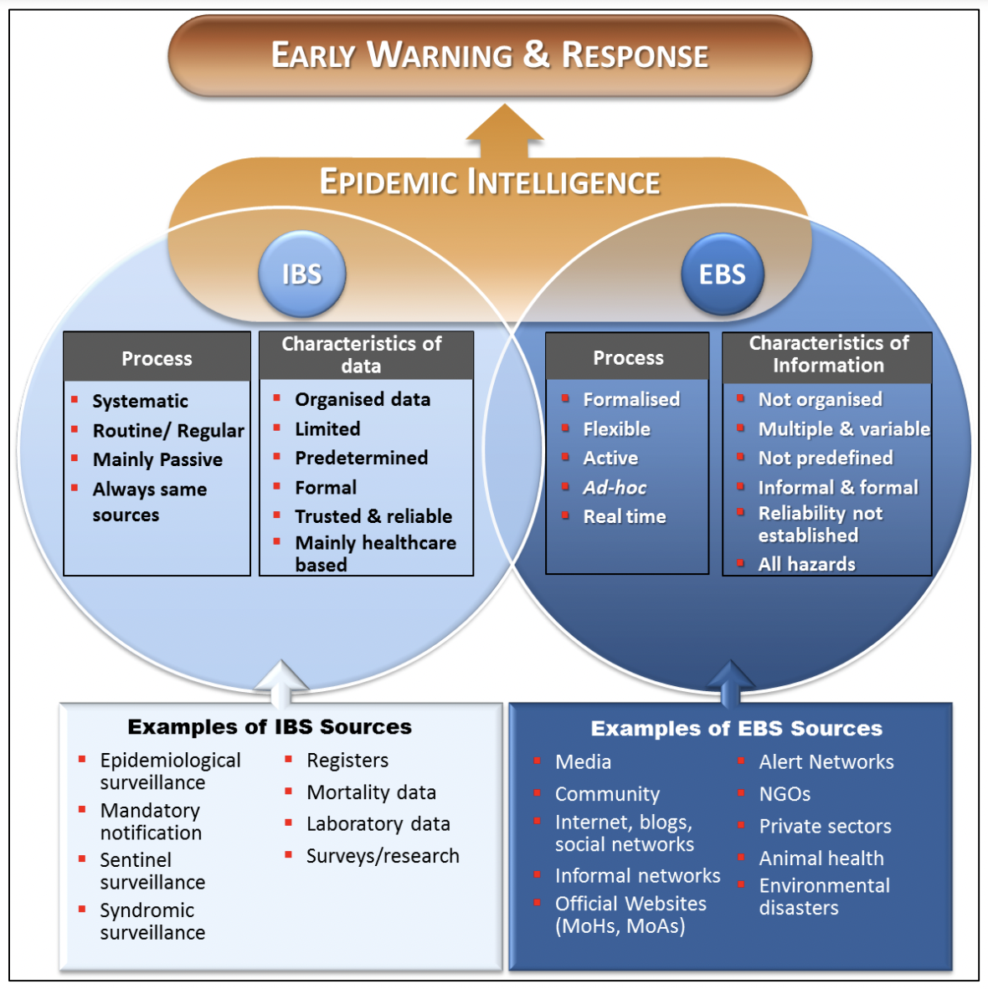

It is important to recognize the differences between indicator-based surveillance (IBS) and event-based surveillance (EBS)—especially that which may involve physicians, healthcare staff, and community health workers— as well as the interactions between the two. In this context, while indicator-based surveillance tracks diseases through routine, structured data, event-based surveillance detects new outbreaks from unstructured, often un-verified sources (Figure 1).12Therefore, a physician reporting a suspected case of filovirus disease would be considered EBS as it is an alert of a possible event that has not been confirmed through structured reporting systems. If the case report becomes confirmed through laboratory confirmation and is reported through a national surveillance platform, then subsequent outbreak surveillance would fall into IBS. Our analysis focuses on initial alerts in filovirus outbreaks, and thus largely concerns EBS.

**Figure 1.** From WHO Global Capacities and Response,12 demonstrating the delineation between indicator-based surveillance and event-based surveillance with examples of each. Physician reporting of an unverified case would fall under event-based surveillance.

There are numerous literature reviews that have explored topics such as clinical disease, transmission dynamics, various risk factors, and control methods (such as contact-tracing, quarantines, and vaccinations). However, clear gaps in knowledge exist that we address through this literature review. Currently, few, if any, sources comprehensively detail the initial signs of historical filovirus outbreaks, opting instead to describe responses after an outbreak has been established for public health measures. This review focused on patterns to be observed that may signal the start of an outbreak and constitute an early alert. Given the continued and seemingly increasing frequency of filovirus outbreaks, it follows that consideration should be given to early identification of outbreaks as well as to response.

The primary aim of this literature review was to explore early warning signs of filovirus outbreaks by analyzing patterns in the first cases of all documented outbreaks associated with community transmission. The ultimate aim of the study was to improve early detection and thus inform more practical applications for public health strategies. We hypothesized that filovirus outbreaks, in general, are consistently identified by astute, on-the-ground physicians as part of EBS, as opposed to the broader, more formalized surveillance systems of IBS.

For this review, we proceeded through several objectives. Firstly, we characterized the common features of early cases in filovirus outbreaks by conducting a focused review of literature surrounding each outbreak. Second, we analyzed patterns in initial identification and reporting— by whom, when, how, and identified challenges that may have led to delays/disruptions in these processes. This included critical examinations of how in-place surveillance systems, formal, informal, or non-existent, influenced these reports. Lastly, we synthesized and summarized these findings with the purpose of considering how this knowledge could affect future outbreak surveillance, detection practice, and preparedness. Through this structured investigation, we constructed an evidence-base for early outbreak detection vital for filovirus outbreaks that may also be applicable to the broader challenges surrounding surveillance for other emerging infectious zoonotic diseases.

## Aims and Objectives

The primary aim of this review was to characterize the early warning signs and initial reporting patterns of filovirus outbreaks to evaluate the hypothesis that the initial detection of filovirus outbreaks has a greater reliance on the clinical judgement of on-the-ground physicians/health care workers (HCW)s and EBS than on formalized surveillance systems. Through investigating the commonalities in the emergence of filovirus outbreaks, it may be possible to identify gaps in surveillance methodology and to provide evidence-based recommendations for strengthening preparedness and response strategies for future outbreaks.

## 

## Methods

### Study Type

We undertook an integrative literature review to synthesize the quantitative and qualitative evidence surrounding the early stages of 46 filovirus outbreaks. This methodology allowed for the combination and analysis across multiple information types: peer reviewed literature, official outbreak reports/news, and other official documentation, including first-person accounts.13,14 The review was designed using the Preferred Reporting Items for Systematic Reviews and Meta-Analyses (PRISMA) 2020 principles, which ensure methodological rigor as well as transparent searches, results, and reporting.15  The 2020 PRISMA checklist is included in Appendix A. The review protocol was not registered.

### Information Sources and Search Strategy

We identified relevant literature in five electronic databases, chosen to increase the reach of searches by including papers written by authors outside of North America and Europe (specifically those within Africa, which may be the first reports of filovirus outbreaks). These included Ovid Medline (coverage dates: 1946-Present), Ovid EMBASE (1971-Present), Web of Science (1900-Present), Ovid Global Health (1973-Present), and Africa-Wide Information (1800-Present). Initial searches were conducted between June 23-30, 2025. We examined reports from official government and organizational websites, such as the U.S. Centers for Disease Control and Prevention (CDC)16,17 and the World Health Organization (WHO) to form the initial list of outbreaks used to determine subsequent search strings. In later analysis, for outbreaks for which there were discrepancies between reports or lacked clarity on certain extraction parameters, CDC outbreak-relevant materials and webpages were utilized as the ultimate authority.

A sensitive and specific search strategy for each historical outbreak was defined, combining keywords and controlled vocabulary terms that often mapped to pre-existing database subject headings and exploding topics in eligible databases. This included the inclusion of a) virus keywords (e.g. “Ebola” or “Ebolavirus” or “Zaire”, “Marburg” or “Marburg virus” or “Marburg virus disease”); b) the outbreak year; and c) geography (country, region, town) where the outbreak occurred. If needed, other keyword groups were added to increase specificity (e.g. outbreak and spillover keywords). We manually translated all search strings from the original OVID MEDLINE search (Table 2) for use in other databases. Detailed documentation of the search strategy can be found in Appendix B, vetted by an LSHTM librarian.

**Table 2.** Search Strategy used in OVID MEDLINE. Searches were created in consultation with an LSHTM librarian. Searches conducted between 17.06.2025 and 19.06.2025.

|  |  |
| --- | --- |
| **Search Blocks** | **Search Terms** |
| **Virus** | Filoviridae Infections/ or exp Filoviridae/ or filovir*.ti,ab. or Hemorrhagic Fevers, Viral/ AND (Marburgvirus/ or Marburg Virus Disease/ or Marburg.ti,ab.) OR (Ebolavirus/ or Hemorrhagic Fever, Ebola/ or Ebola.ti,ab.) |
| **Country** | [Country]** |
| **Year** | [Year] |
| **Outbreak** | Disease Outbreaks/ or outbreak*.ti,ab. OR epidemic*.ti,ab. or Disease Outbreaks/ or Epidemics/ OR Zoonoses/ or zoono*.ti,ab. or Communicable Diseases, Emerging/ OR Zoonoses/ or spillover*.ti,ab. |
| **Keywords** | ("index case" or "primary case" or "first case").ti,ab. OR (early and (signal* or warning* or detection or identification*)).ti,ab. OR Public Health Surveillance/ or Sentinel Surveillance/ or surveil*.ti,ab. OR Epidemiology/ or Epidemiological Monitoring/ or Epidemiologic Studies/ or epidemiolog*.ti,ab. or Epidemiologic Methods/ |
| **Clinicians** | (physician* or clinician* or "health care worker*" or doctor*).ti,ab. AND (report* or recogni* or identif* or diagnos*).ti,ab. |
| **Epidemiology** | signal*.ti,ab. OR observation*.ti,ab. OR recognition*.ti,ab. OR identification*.ti,ab. OR sensing.ti,ab. OR discover*.ti,ab. OR monitor*.ti,ab. OR supervision.ti,ab. OR system*.ti,ab. |

### Literature Eligibility Criteria

**Table 3.** Study eligibility criteria, as defined by PICOST.18

| **PICOST** | **Description** |
| --- | --- |
| **(P)opulation** | Marburg virus or Ebola virus outbreaks associated with community transmission |
| **(I)ntervention** | Early signals and surveillance activity |
| **(C)omparison** | Event-based, clinician surveillance vs. indicator-based surveillance |
| **(O)utcome** | Initial detection, timeliness, nosocomial transmission/amplification, outbreak size/severity |
| **(S)etting** | Peer-reviewed publications, outbreak and field investigations, epidemiological reports; review articles for reference mining |
| **(T)ime** | 1976-2025; languages: French and English |

Study inclusions and exclusions were based on predefined eligibility criteria, built upon the Population, Intervention, Comparison, Outcome, Study design/setting and Time (PICOST) framework (Table 3).18 These criteria aimed to narrow the search to focus literature relevant to the initial stages of filovirus outbreaks, including their emergence, first cases, and reporting.

#### Inclusion Criteria

* Studies that directly reported on an outbreak of either Ebola virus disease or Marburg virus disease associated with community transmission.
* Studies including specific and relevant details of initial cases, the circumstances surrounding the beginning of the outbreak, and/or surveillance mechanisms in place when the disease emerged.
* Peer-reviewed primary research articles and contemporary or retrospective outbreak reports or epidemiological analyses. Review articles that contained comparable and pertinent information were not used for primary extractions but for reference mining (see below).

#### Exclusion Criteria

* Studies of outbreaks originating from laboratory accidents or leaks, as well as those caused by international importations from already-recognized cases and reported outbreaks.
* Studies that did not report on epidemiology or primary data surrounding emergence of filoviruses (ie, a mathematical modeling study of theoretical vaccination strategies).
* Studies published in languages other than French or English.

### Study Selection

We imported all records from searches into Zotero citation reference software, removing duplicate records prior to screening. A single reviewer (MF) performed the screenings for title, then abstract. We then reviewed retrieved articles in full against the eligibility criteria. Due to the nature of the review method as an outbreak-by-outbreak literature search, some reports, including reviews covering multiple outbreaks, were pulled more than once in the literature search process. We adjusted the final numbers shown in the PRISMA flow diagram (Figure 2, Results) to prevent double-counting of sources.

### Source Credibility

Formalized bias-risk tools are not always well-suited to integrative reviews, especially when the evidence is non-empirical and is derived from a wide variety of non-standardized primary sources.19 Our study, centered around outbreak reports, case series, and epidemiological studies, fell into this category, especially given that our goal was not to estimate effects but to examine cross-cutting themes and patterns across a highly heterogeneous body of work. Therefore, we did not utilize a tool to exclude studies based on methodological quality, instead focusing on the credibility of information the article contained based on its accuracy and consistency with other sources and known factors about the outbreak.

### Data Extraction

We used a standardized extraction form (Appendix C) applied by a single reviewer (MF), first to a pilot set, and then to all reports. At this stage, we excluded review articles from primary data collection/extraction. Instead, we scanned review articles for both agreement with primary data sources and for new relevant primary reports. If sources were identified that had not been captured by the original search and screening process, they were included in the study.

The general extraction fields were as follows:

* Outbreak identifiers (virus, outbreak year, geography).
* Early cases and transmission (index/primary case information, exposures, healthcare contact, nosocomial transmission).
* Reporting and surveillance structure and challenges (outbreak report source(s), challenges in reporting, epidemiological investigation, infection prevention and control (IPC), One Health).
* Outcomes and notes (Cases, deaths, CFR, relevant quotes on outcome and outbreak control).

As the unit of analysis was the outbreak, which are often reported on by multiple sources, occasional discrepancies arose. These were resolved via WHO/CDC sources, which were used as the definitive authority on outbreak characteristics.

### Quantitative Analysis

#### Software Usage

We performed screening and citation management in Zotero (v7.0.22) and data extraction in Microsoft Excel (v16.99.2). We conducted analyses and produced figures in R Studio (v2024.12.1+563) using base R and the external packages readr, dplyr, and ggplot2. For outbreak mapping we used curated outbreak statistics and QGIS (v7.0.22) software, as well as OpenStreetMap ([https://www.openstreetmap.org](https://www.openstreetmap.org/)), GoogleEarth (v7.3), and ESRI Reference Overlay.

#### Statistical Analysis

We summarized outbreak-level variables utilizing counts and percentages for categorical variables (such as report type) and medians with interquartile ranges for continuous variables (such as time to outbreak declaration) via R software.

We utilized two-sided p-values for Fisher’s exact tests (designed to be able to handle limited data) for exploration of the associations between categorical variables. This is a non-parametric test well-suited to small replicate counts when the assumptions for chi-square analysis are frequently violated. For comparing continuous variables, such as the time between case recognition and outbreak declaration, we used the Mann-Whitney U test (or Wilcoxon rank-sum test). As a non-parametric test, it is more suited to our outbreak data because it does not assume a normal distribution as in t-tests. Given the likely skew of our data and the low number of replicates, this test is the most appropriate to determine central tendency. In an expansion of the Mann-Whitney U test, we used the Kruskal-Wallis H test (also called the one-way ANOVA on ranks, as it is the non-parametric equivalent of a one-way ANOVA) to compare continuous outcomes across more than two independent groups. All reported p-values are two-sided, and unadjusted for multiple comparisons, indicating strength of observed patterns in data instead of proof of association.

#### Visualizations

We performed and plotted all visualizations and calculations in R. Code for plots can be found in Appendix D and at [https://github.com/Early-Signals-and-Surveillance-Challenges-in-Filovirus-Outbreaks/tree/main](https://github.com/feeromerline/Early-Signals-and-Surveillance-Challenges-in-Filovirus-Outbreaks/tree/main).

### Narrative Analysis

We conducted a narrative synthesis following the guidance outlined by Popay et al. (2006)20, appropriate for our outbreak review structure. Utilizing structured data-charting21 for scoping reviews, we charted information for each outbreak into a standardized extraction document, including quotes directly from sources when relevant.21 These charted fields, notes, and quotes were reviewed and grouped into recurring patterns and themes across outbreaks, which appeared naturally and explicitly, rather than being revealed by formal coding.23 We used these themes to build our narrative analysis, with integrated quotes and outbreak-case vignettes when particular outbreaks exemplified certain through lines.

Wherever possible, we linked narrative themes from the outbreak to the quantitative data findings. For all qualitative data, missing and non-applicable data are reported in Table 4.

### Ethics

As this review utilized publicly available data, did not involve human participants, and did not contain identifiable data, ethics approval was not required.

## Results

### Literature Search

We collected a total of 7,276 records on the first search from the five electronic databases, with approximately the same number of records coming from each database, reducing the probability of bias from over-reliance on one database. We screened a total of 1,892 unique records. We then assessed 274 records that met the requirements for full-text retrieval. All but 94 were excluded, with an additional 5 identified through reference mining, yielding a total of 99 reports for data extraction. A complete citation list of the included reports can be found in Appendix E.

**Figure 2.** PRISMA flow diagram for literature review, adapted from Page et al., 2021.15

We created a table containing the most relevant outbreak data for both EVD and MVD, combining data from all sources into a definitive block for each outbreak (Table 4). We used these data for quantitative analyses, where “Not Recorded (NR)”, meaning the included literature sources did not contain the information, was distinguishable from “Not Applicable (N/A)”, which referred to structural inabilities of the dataset (e.g. a cluster of recorded cases cannot have a single sex).

A geographic representation of the outbreaks is presented in Figure 3.

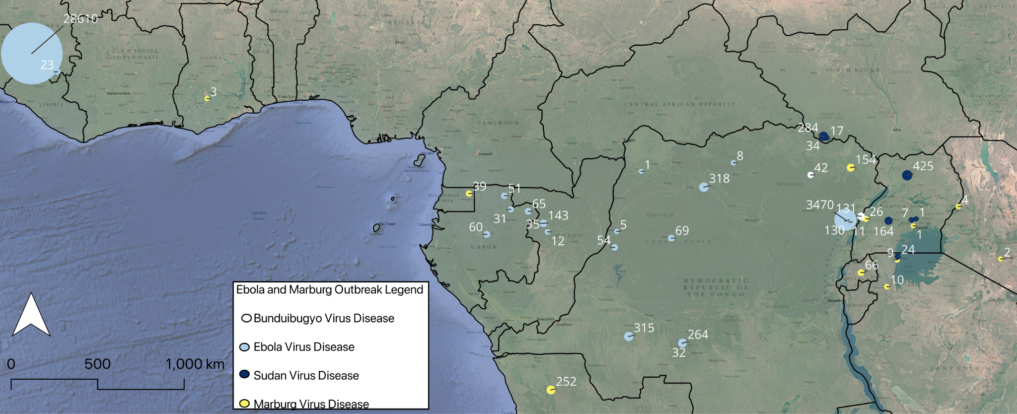

Basemaps: Google Satellite, https://mt1.google.com/vt/lyrs=s&x={x}&y={y}&z={z} and ESRI Reference Overlay,https://server.arcgisonline.com/ArcGIS/rest/services/Reference/World_Reference_Overlay/MapServer/tile/{z}/{y}/{x}; Projection: WGS84/ESRI.

**Figure 3.** Geographic distribution of the 46 Marburg virus and Ebola virus outbreaks included in our study (1976-2025). Labels represent the number of cases reported in each outbreak. Outbreaks showed clustering in Central/Eastern Africa, particularly in heavily forested areas. Outbreaks are reported by color: Zaire ebolavirus (EBOV, n=23), Sudan ebolavirus (SUDV, n=8), Bundibugyo ebolavirus (BDBV, n=2), and Marburg virus (MARV), n=13). Outbreak size visualized on Flannery scale. Coordinate data retrieved from https://planet.openstreetmap.org.

#### 

**Table 4.** All 46 outbreaks included in this study, as well as their characteristics relevant to our analysis. Fields reported as “NR” were not recorded in the literature reviewed in this study, while fields reported as “N/A” were not applicable due to a previous field(s)’ state.

* Outbreak Statistics include both probable and confirmed cases. If there were discrepancies in the literature, CDC documentation16,17 was treated as definitive on final counts.

| **Outbreak** | | | | | **Index Case(s)** | | | | **Surveillance and Reporting** | | **Outbreak Statistics\*** | | | | |
| --- | --- | --- | --- | --- | --- | --- | --- | --- | --- | --- | --- | --- | --- | --- | --- |
| **Virus** | **Start Year** | **Country** | **Region/**  **Province** | **Town/**  **Village/**  **Locality** | **Report Type** | **Sex** | **With Haemorrhage**  **(Y/N)** | **Exposure Known (Y/N)** | **Report Source** | **Days to Declaration** | **Health Care Worker Infections**  **(Y/N)** | **Cases** | | **Deaths** | **CFR** |
| Ebola, Bundibugyo | 2007 | Uganda | Bundibugyo | Kasitu, Bundibugyo town council, Bubukwanga, Busaru | Single | Female | N | N | Physician/  Hospital Staff | 24 | Y | 131 | | 42 | 32 |
| Ebola, Bundibugyo | 2012 | The Democratic Republic of the Congo | Orientale | Isiro Health Zone | Single | Female | NR | Y, HCW | Physician/  Hospital Staff and Community | 15 | Y | 42 | | 28 | 54 |
| Ebola, Sudan | 1976 | Sudan | N/A | Nzara, Maridi, Tembura, Juba | Single | Male | Y | Y, factory | Physician/  Hospital Staff | NR | Y | 284 | | 151 | 53 |
| Ebola, Sudan | 1979 | Sudan | N/A | Nzara, Yambio | Single | Male | NR | Y, factory | Physician/  Hospital Staff | NR | Y | 34 | | 22 | 65 |
| Ebola, Sudan | 2000 | Uganda | Gulu, Masindi, Mbara | N/A | Cluster | N/A | Y | N/A | Physician/  Hospital Staff | 5 | Y | 425 | | 224 | 53 |
| **Virus** | **Start Year** | **Country** | **Region/**  **Province** | **Town/**  **Village/**  **Locality** | **Report Type** | **Sex** | **With Haemorrhage**  **(Y/N)** | **Exposure Known (Y/N)** | **Report Source** | **Days to declaration** | **Health Care Worker Infections**  **(Y/N)** | | **Cases** | **Deaths** | **CFR** |
| Ebola, Sudan | 2004 | Uganda | N/A | Yambio | Single | Male | NR | Y, hunting | Physician/  Hospital Staff | 15 | Y | | 17 | 7 | 41 |
| Ebola, Sudan | 2011 | Uganda | Luwero | Nakisamata | Single | Female | Y | N | Physician/  Hospital Staff | 0 | N | | 1 | 1 | 100 |
| Ebola, Sudan | 2012 | Uganda | Luwero | Kakute | Single | Male | NR | NR | Physician/  Hospital Staff | >60 | Y | | 7 | 4 | 57 |
| Ebola, Sudan | 2012 | Uganda | Kibale | N/A | Cluster | N/A | Y | N/A | Physician/  Hospital Staff | 18 | Y | | 24 | 17 | 71 |
| Ebola, Sudan | 2022 | Uganda | Madudu | Mubende, Ngabano | Single | Male | Y | N | Physician/  Hospital Staff | 3 | Y | | 164 | 55 | 34 |
| Ebola, Zaire | 1976 | The Democratic Republic of the Congo | Équateur | Bumba Zone | Single | Male | Y | N | Physician/  Hospital Staff | 10 | Y | | 318 | 280 | 88 |
| Ebola, Zaire | 1977 | The Democratic Republic of the Congo | Congo Basin | Tandala | Single | Female | Y | N | Physician/  Hospital Staff | NR | N | | 1 | 1 | 100 |
| Ebola, Zaire | 1994 | Gabon | Makakou | Minkebe | Cluster | N/A | NR | N/A | Physician/  Hospital Staff and Community | NR | NR | | 51 | 31 | 61 |
| Ebola, Zaire | 1995 | The Democratic Republic of the Congo | N/A | Kikwit | Single | Male | N | Y, HCW | Physician/  Hospital Staff | 5 | Y | | 315 | 254 | 81 |
| **Virus** | **Start Year** | **Country** | **Region/**  **Province** | **Town/**  **Village/**  **Locality** | **Report Type** | **Sex** | **With Haemorrhage**  **(Y/N)** | **Exposure Known (Y/N)** | **Report Source** | **Days to declaration** | **Health Care Worker Infections**  **(Y/N)** | | **Cases** | **Deaths** | **CFR** |
| Ebola, Zaire | 1996 | Gabon | Ogooyu-Ivindo | Mayibout II | Cluster | N/A | NR | Y, butchering | Physician/  Hospital Staff | NR | NR | | 31 | 21 | 68 |
| Ebola, Zaire | 1996 | Gabon | Ogooyu-Ivindo | Booué | Cluster | N/A | NR | Y, hunting | Physician/  Hospital Staff | >30 | Y | | 60 | 45 | 75 |
| Ebola, Zaire | 2001 | Gabon | Ogooue-Ivindo | Mekambo | Single | Female | N | N | Physician/  Hospital Staff | 25 | Y | | 65 | 53 | 81 |
| Ebola, Zaire | 2003 | Republic of the Congo | Cuvette Ouest | Mbomo, Kéllé | Cluster | N/A | N | Y, hunting, butchering | Physician/  Hospital Staff | 21 | Y | | 143 | 128 | 89 |
| Ebola, Zaire | 2003 | Republic of the Congo | Cuvette Ouest | Mbomo | Cluster | N/A | NR | Y, hunting | NR | NR | Y | | 35 | 29 | 83 |
| Ebola, Zaire | 2005 | Republic of the Congo | Cuvette Ouest | Etoumbi | Cluster | N/A | Y | Y, hunting | Physician/  Hospital Staff | 12 | N | | 12 | 10 | 83 |
| Ebola, Zaire | 2007 | The Democratic Republic of the Congo | Kasi Occidental | Luebo and Mweka | Single | Female | Y | N | NR | 19 | Y | | 264 | 198 | 71 |
| Ebola, Zaire | 2008 | The Democratic Republic of the Congo | Kasi Occidental | Luebo and Mweka | Single | Female | Y | N | Physician/  Hospital Staff | >30 | Y | | 32 | 15 | 47 |
| Ebola, Zaire | 2013 | Guinea/West Africa | Gueckedou, Macenta | Meliandou | Cluster | N/A | NR | NR | Physician/  Hospital Staff | 12 | Y | | 28610 | 11308 | 39 |
| **Virus** | **Start Year** | **Country** | **Region/**  **Province** | **Town/**  **Village/**  **Locality** | **Report Type** | **Sex** | **With Haemorrhage**  **(Y/N)** | **Exposure Known (Y/N)** | **Report Source** | **Days to declaration** | **Health Care Worker Infections**  **(Y/N)** | | **Cases** | **Deaths** | **CFR** |
| Ebola, Zaire | 2014 | The Democratic Republic of the Congo | Équateur | Boende | Single | Female | NR | Y, butchering | Physician/  Hospital Staff | 6 | Y | | 69 | 49 | 71 |
| Ebola, Zaire | 2017 | The Democratic Republic of the Congo | Bas Uele | Likati District | Single | Male | NR | Y, butchering | Physician/  Hospital Staff | 4 | N | | 8 | 4 | 50 |
| Ebola, Zaire | 2018 | The Democratic Republic of the Congo | Équateur | Bikoro | Cluster | N/A | NR | N/A | Physician/  Hospital Staff | NR | Y | | 54 | 33 | 61 |
| Ebola, Zaire | 2018 | The Democratic Republic of the Congo | North Kivu | Mangina | Cluster | N/A | NR | N/A | Physician/  Hospital Staff | 4 | Y | | 3470 | 2287 | 66 |
| Ebola, Zaire | 2020 | The Democratic Republic of the Congo | Équateur | Mbandaka | Cluster | N/A | NR | N/A | Physician/  Hospital Staff | NR | Y | | 130 | 55 | 42 |
| Ebola, Zaire | 2021 | The Democratic Republic of the Congo | North Kivu | Katwa, Mangurudjipta | Single | Female | NR | Y, sexual transmission | Physician/  Hospital Staff | 13 | Y | | 12 | 6 | 50 |
| Ebola, Zaire | 2021 | The Democratic Republic of the Congo | North Kivu | Beni Health Zone | Single | Male | Y | N | Physician/  Hospital Staff | 0 | Y | | 11 | 9 | 82 |
| **Virus** | **Start Year** | **Country** | **Region/**  **Province** | **Town/**  **Village/**  **Locality** | **Report Type** | **Sex** | **With Haemorrhage**  **(Y/N)** | **Exposure Known (Y/N)** | **Report Source** | **Days to declaration** | **Health Care Worker Infections**  **(Y/N)** | | **Cases** | **Deaths** | **CFR** |
| Ebola, Zaire | 2021 | Guinea | N’Zérékoré | Gouéké | Cluster | N/A | N | Y, HCW | Community | 3 | Y | | 23 | 12 | 52 |
| Ebola, Zaire | 2022 | The Democratic Republic of the Congo | Équateur | Mbandaka | Single | Male | N | N | Physician/  Hospital Staff | NR | Y | | 5 | 5 | 100 |
| Ebola, Zaire | 2022 | The Democratic Republic of the Congo | North Kivu | Beni Health Zone | Single | Female | N | N | Physician/  Hospital Staff | 6 | N | | 1 | 1 | 100 |
| Marburg | 1980 | Kenya | Western Province | Nairobi | Single | Male | Y | Y, cave | Physician/  Hospital Staff | 0 | Y | | 2 | 1 | 50 |
| Marburg | 1987 | Kenya | NR | NR | Single | Male | N | Y, cave | Physician/  Hospital Staff | Not declared | N | | 1 | 1 | 100 |
| Marburg | 1998 | The Democratic Republic of the Congo | Haut-Uélé District | Durba | Cluster | N/A | NR | N/A | Physician/  Hospital Staff | >180 | Y | | 154 | 128 | 83 |
| Marburg | 2004 | Angola | Uige | NR | Cluster | N/A | NR | N/A | Physician/  Hospital Staff | >90 | Y | | 252 | 227 | 90 |
| Marburg | 2007 | Uganda | Kamwenge | N/A | Single | Male | N | Y, mine | Physician/  Hospital Staff | 17 | N | | 4 | 1 | 25 |
| **Virus** | **Start Year** | **Country** | **Region/**  **Province** | **Town/**  **Village/**  **Locality** | **Report Type** | **Sex** | **With Haemorrhage**  **(Y/N)** | **Exposure Known (Y/N)** | **Report Source** | **Days to declaration** | **Health Care Worker Infections**  **(Y/N)** | | **Cases** | **Deaths** | **CFR** |
| Marburg | 2012 | Uganda | Kabale, Ibanda, Mbarara, Kampala | N/A | Cluster | N/A | NR | N/A | Physician/  Hospital Staff | 2 | N | | 26 | 15 | 58 |
| Marburg | 2014 | Uganda | Kampala | Kampala | Single | Male | N | N | Physician/  Hospital Staff | 13 | N | | 1 | 1 | 100 |
| Marburg | 2017 | Uganda | Kween District | Tulwo | Single | Male | N | Y, cave | Physician/  Hospital Staff | 2 | N | | 4 | 3 | 75 |
| Marburg | 2022 | Ghana | Ashanti | Bekwai | Single | Male | Y | N | Physician/  Hospital Staff | 6 | N | | 3 | 2 | 67 |
| Marburg | 2023 | Equatorial Guinea | Kie-Ntem, Littoral, and Centro Sur | Nsock, Nsomo | Cluster | N/A | Y | N/A | NR | 1 | Y | | 39 | 35 | 90 |
| Marburg | 2023 | Tanzania | Kagera | Bukoba | Single | Male | Y | Y, cave | Physician/  Hospital Staff | 22 | Y | | 9 | 6 | 67 |
| Marburg | 2024 | Rwanda | N/A | Kigali | Single | Male | N | Y, mine | Physician/  Hospital Staff | NR | Y | | 66 | 15 | 23 |
| Marburg | 2025 | Tanzania | Kagera | Biharamulo | Single | Female | NR | NR | Physician/  Hospital Staff | NR | Y | | 10 | 10 | 100 |

#### 

### Report Source

The majority (87%) of Ebola virus and Marburg virus disease reports came from physicians or hospital staff. Community alerts in conjunction with physicians/hospital staff accounted for 4%, while 2% were made by the community alone. No specific source was recorded for 7%. All of the outbreaks for which the report type was available (n = 43) were reported through EBS; no outbreaks were identified through indicator-based surveillance. These trends have not changed appreciably over time (Figure 4, Fisher’s exact, p > 0.5).

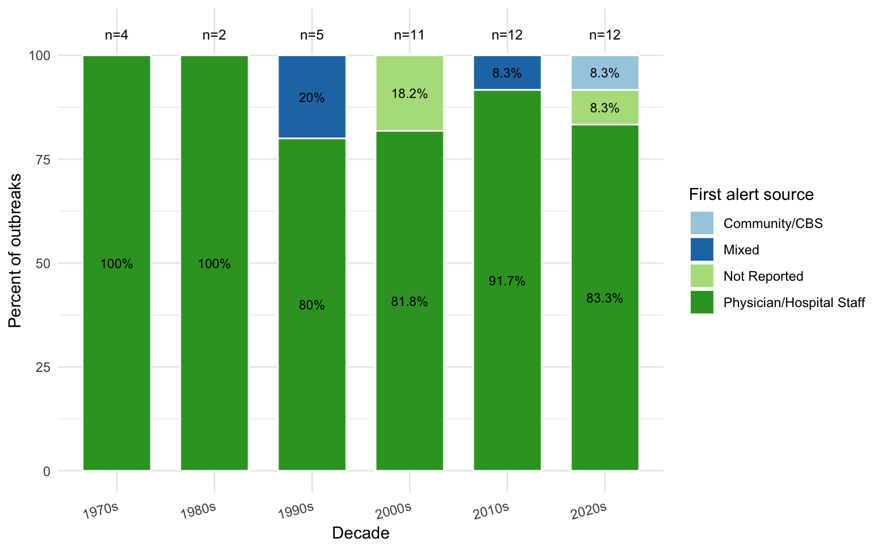

**Figure 4.** First alert source by decade. Proportions did not change across eras (Fisher’s p > 0.5).

Qualitative descriptions also indicated that clinic/hospital and staff recognition (whether of a patient or another staff member) was consistently the genesis of alerts, with occasional community alerts only coming after prolonged clusters of unusual disease and deaths.

### Index Cases

First reports were driven by either an individual index case or a cluster of suspicious cases/deaths. The number of reports originating from a single index case (n=29) was higher than those originating from clusters (n=17) and did not vary significantly by virus (Figure 5, Fisher’s exact, p > 0.5). Note that the highly heterogeneous sample sizes should be considered for these results.

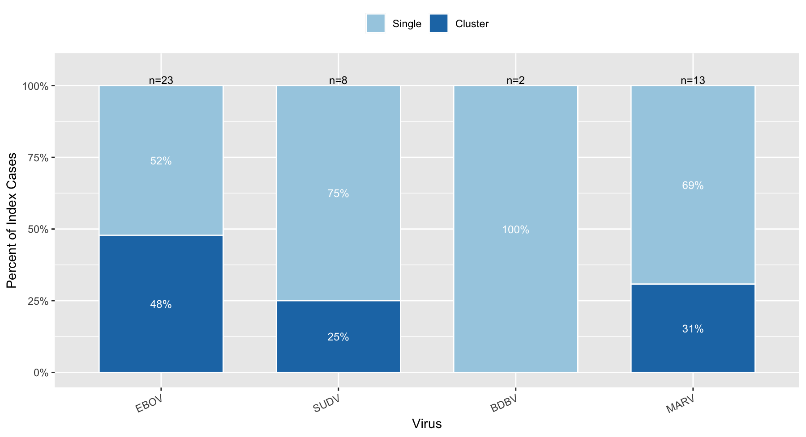

**Figure 5.** First signal type by virus. Distributions did not change significantly by virus (Fisher’s exact p > 0.5). EBOV, Ebola Zaire virus; SUDV, Ebola Sudan virus; BDBV, Ebola Bundibugyo virus; MARV, Marburg virus.

Cluster alerts were often from a physician reporting a group of unusual deaths in a particular area over a given time period within the community or as healthcare workers (HCWs) rapidly falling ill with a similar clinical syndrome of a patient for whom they had recently provided care. Most single index case reports came after clinician suspicion at the point of care.

In single index case reports (n=29), a greater number of the index cases were male (n=18, female = 11). This male index skew was true for all viruses except BDBV, for which both outbreaks’ index cases were female (Appendix F).

In both quantitative and qualitative analysis, no consensus characterization of an index case emerged. The age of index cases ranged from an infant to 56 years (Median = 31.5) with both males (62%) and females (38%). Single index cases were family members of someone who had previously fallen ill, had occupational exposures to ill persons (HCWs, nurses) or zoonotic reservoirs (miners, hunters, factory workers), or were the direct family member of one of these occupations in 37% of the outbreaks.

The route of presumed primary introduction into humans was known for 61% (20/33) of outbreaks with exposure recorded, varying slightly between viruses: EBOV was most often related to hunting and butchering, while MARV infection often involved exposure to caves, mines, and bats.

### Diagnosis and Nosocomial Effects

Of the 27 outbreaks for which a description of the index case(s)’ symptoms was provided in the literature, 15 (56%) exhibited haemorrhagic manifestations during disease course. The most reported symptoms of index/primary cases and initial clusters in order of frequency were: high fever, gastrointestinal symptoms (vomiting and diarrhea, pain in abdomen), general malaise (headache, fatigue and weakness, muscle and joint pain, chills/rigor, nausea, loss of appetite), haemorrhagic manifestations, and least commonly, respiratory issues (chest pain, difficulty breathing, hiccups). Haemorrhaging was reported late in the disease-course, long after the infected person was contagious. These non-specific symptoms were reported to be very hard to distinguish clinically from other endemic febrile illnesses across the surveyed literature.

Considerable misdiagnosis of index cases occurred; seven outbreaks’ index case(s) were initially misdiagnosed as malaria or as malaria and bacterial infection, two as typhoid outbreaks, and one as cholera. Descriptive accounts repeatedly asserted that misdiagnosis was common and led to delayed suspicion, delayed isolation, and increased community transmission. It is worth noting that this is likely an under-representation of index misdiagnosis since many outbreaks showed evidence of low-level community transmission occurring over weeks or even months prior to detection.

HCW infections occurred in 76.7% of outbreaks (33/43 with data). There was weak evidence that outbreaks where HCW infections had a longer time to declaration (Mann-Whitney [Wilcoxon rank-sum] p =0.07, 15 days (IQR 5-24) vs 6 days (IQR 2-12), Figure 6).

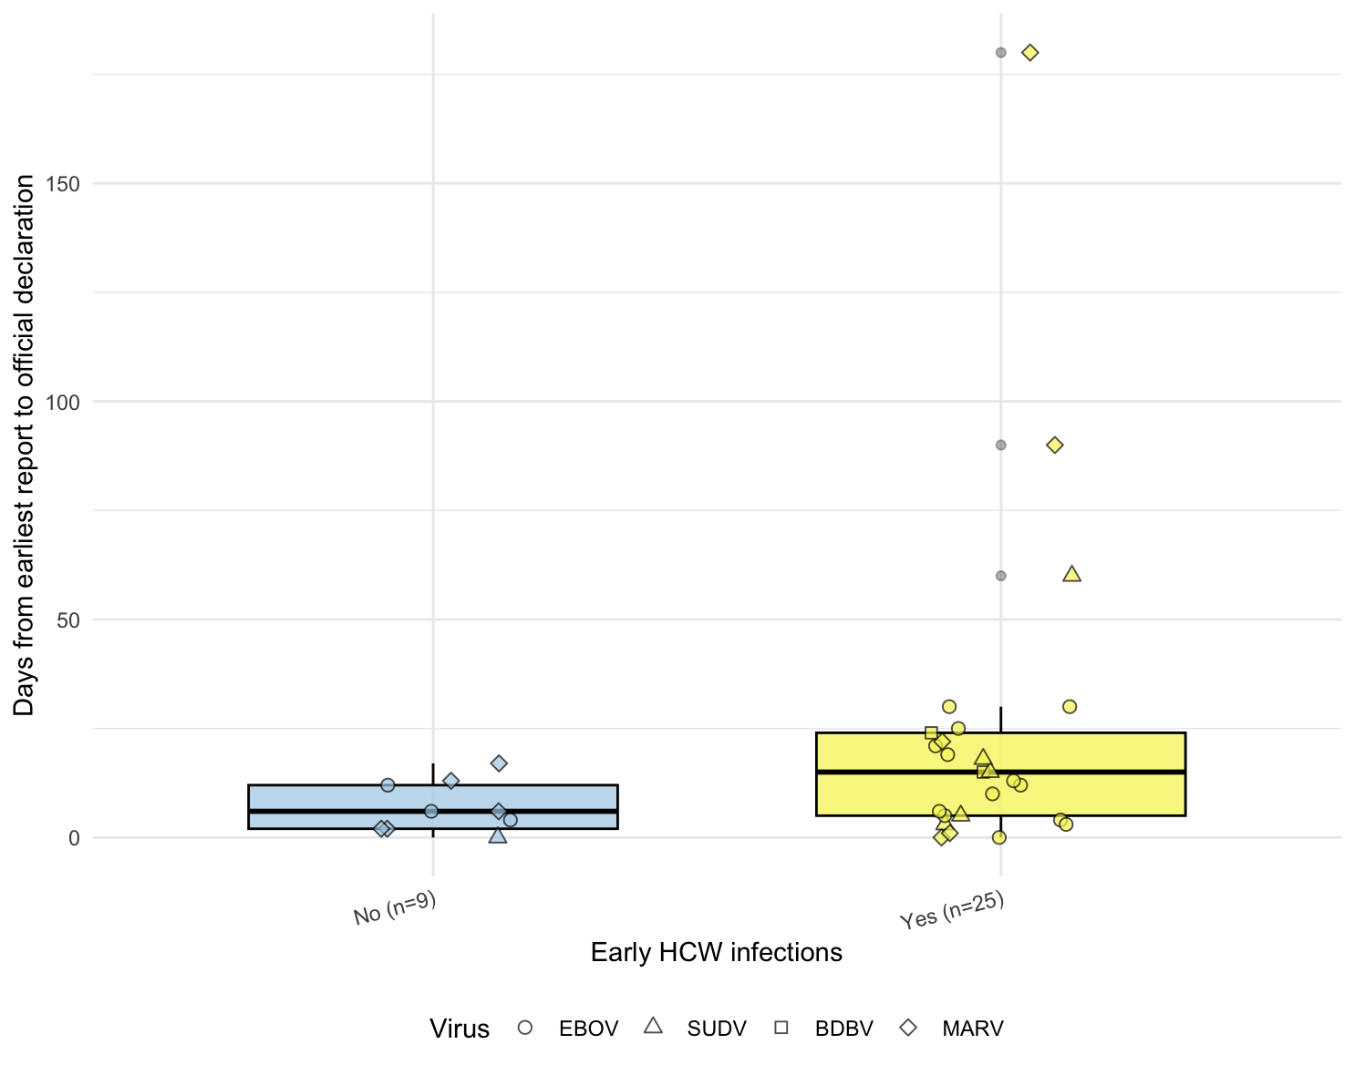

**Figure 6.** Time from the earliest report to official outbreak declaration stratified by HCW infections (Yes/No). Medians (IQR): Yes 15 days (5-24), No 6 days (2-12), Mann-Whitney [Wilcoxon rank-sum] p = 0.07. EBOV, Ebola Zaire virus; SUDV, Ebola Sudan virus; BDBV, Ebola Bundibugyo virus; MARV, Marburg virus.

It was stated in the literature that the actions of hospitals and clinics could curtail an outbreak, i.e. if staff detected, reported, and isolated the index case, outbreaks might be curtailed. However, if the disease was not detected and/or IPC was inadequate, the hospital would become the site of amplification, increasing transmission and exacerbating the outbreak.

### 

### Outbreak Report to Declaration

There was no significant difference in the time to outbreak declaration regarding whether initial detection was via a single case or a cluster (Mann-Whitney [Wilcoxon rank-sum] p > 0.5, Figure 7). Single index outbreak declarations occurred a median of 11.5 days (IQR 4.25-18.50) after initial report, while cluster index outbreak declarations occurred a median of 12 days (IQR 3.75-23.2) after initial report.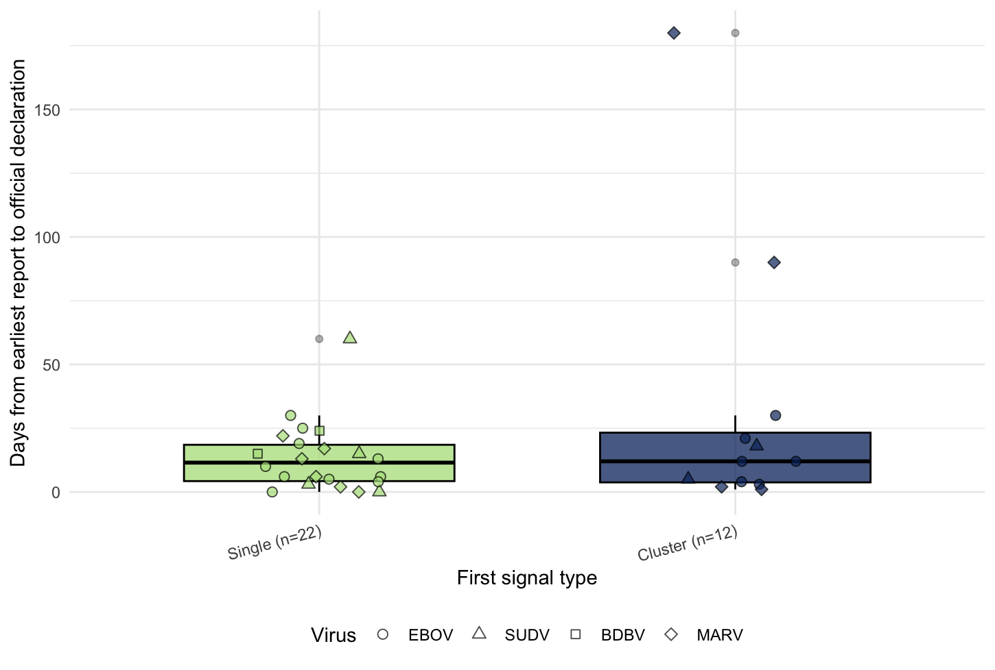

**Figure 7.** Time from the earliest report to official outbreak declaration stratified by single index case vs cluster report type. Medians (IQR): Cluster 12 days (3.75-23.2), Single 11.5 days (4.25-18.50), Mann-Whitney [Wilcoxon rank-sum] p > 0.5. EBOV, Ebola Zaire virus; SUDV, Ebola Sudan virus; BDBV, Ebola Bundibugyo virus; MARV, Marburg virus

The time from the initial outbreak report to official outbreak recognition/declaration decreased over the years since first detection of the filoviruses (Kruskal-Wallis p = 0.03, Figures 8 and 9, Appendix G).

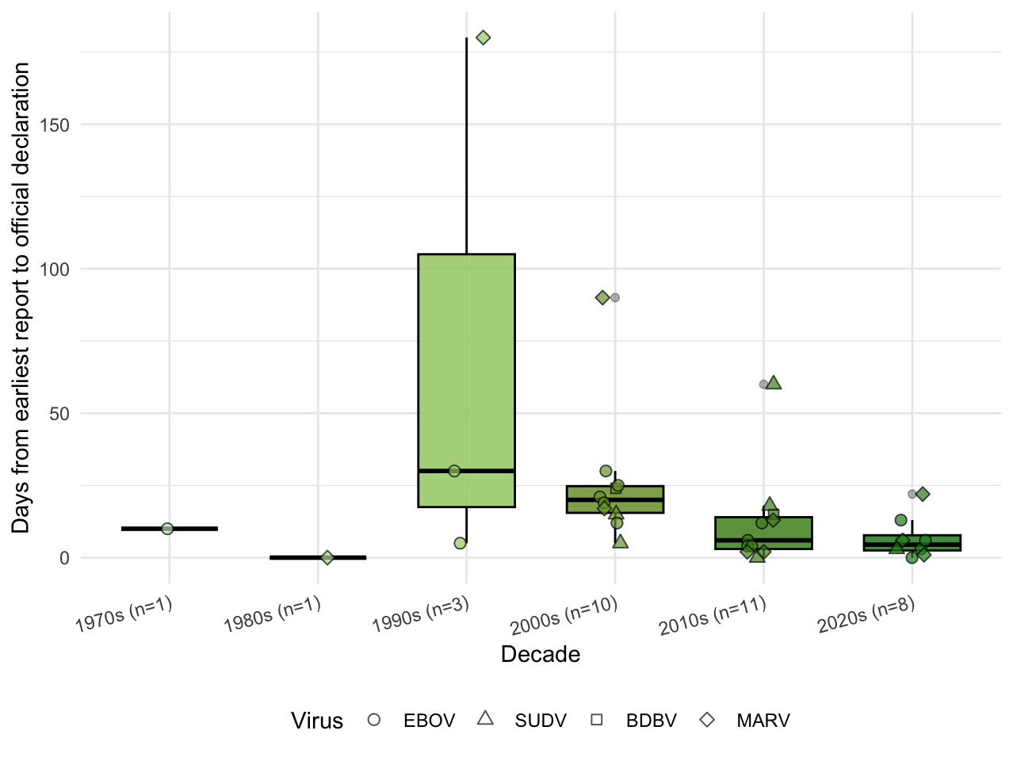

**Figure 8.** Time to official outbreak declaration stratified by era. Kruskal-Wallis p = 0.03.

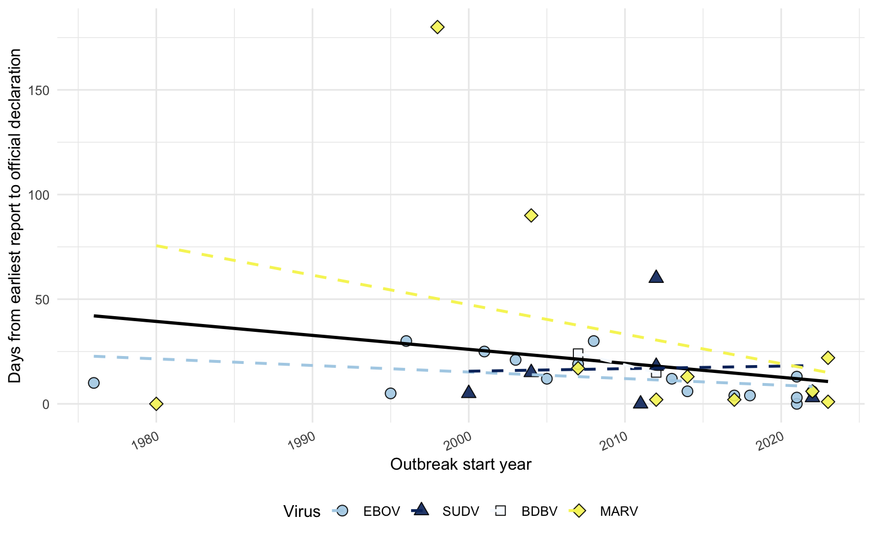

**Figure 9.** Overall trend of initial report to official outbreak declaration time, all viruses. Solid line, global trend; dashed lines, virus-specific trends; shapes, virus species. EBOV, Ebola Zaire virus; SUDV, Ebola Sudan virus; BDBV, Ebola Bundibugyo virus; MARV, Marburg virus.

This trend was particularly notable in the Democratic Republic of the Congo and Uganda, where the majority of Ebola virus disease outbreaks have occurred (Figure 10).

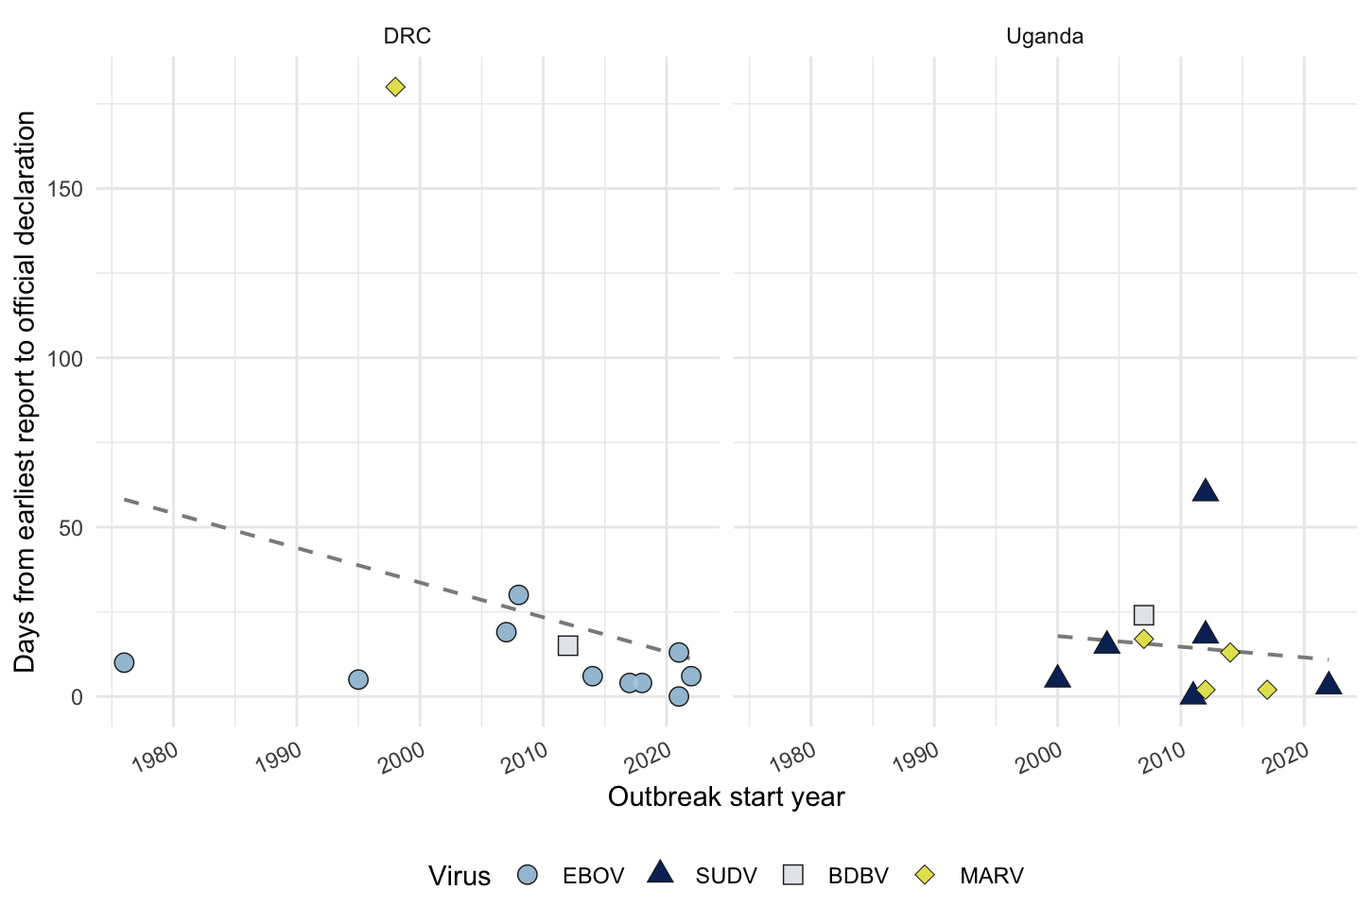

**Figure 10.** Trends of initial report to official outbreak declaration time for The Democratic Republic of the Congo (DRC) and Uganda. Dashed lines, virus-specific trends; shapes, virus species. EBOV, Ebola Zaire virus; SUDV, Ebola Sudan virus; BDBV, Ebola Bundibugyo virus; MARV, Marburg virus.

### One Health

One Health, an approach to infectious disease control and prevention that recognizes the interconnectedness of ecosystem, animal, and human health, was a recurring theme in the data. Animal die-offs, especially in forested areas, were reported in at least 8 filovirus outbreaks (e.g. 1994 EBOV in Gabon), either before or after the outbreak occurred. While relatively unexplored as a surveillance modality, several authors cited animal die-offs as a potential future additional surveillance indicator for VHFs.

## 

## Discussion

Our review of the early signals of filovirus outbreaks spanning decades demonstrates that, while each outbreak is unique, multiple themes continuously arise with implications for the detection, surveillance, reporting, and initial response to these viruses. Specifically, our findings highlight the continued importance of front-line HCWs and EBS for disease detection, even in challenging contexts and settings. Future preparedness for filovirus and other high-impact pathogens may be enhanced by a better understanding of filovirus outbreak signals and how well we respond to them.

### Setting the Scene

As widely known and re-confirmed by our analysis, filovirus outbreaks consistently emerge in regions that are plagued by significant general infrastructure and public health vulnerabilities, most often in underserved and remote areas of Sub-Saharan Africa. Settings such as these have chronically fragmented healthcare coverage and systems, limited infrastructure, and often a scarcity of trained medical personnel. All of these factors, stemming from centuries of unjust and exploitative colonial forces, wars, and corruption, have contributed to an environment with insufficient capacity for baseline surveillance.24 In reference to the 2000 EVD outbreak in the Republic of the Congo, Nkighe et al. stated: “In the Cuvette Ouest County, health services are dysfunctional; few people use the elementary medical services, and most consult traditional healers. The Etoumbi health center has no doctor and no ambulance, and is staffed by nurses”.25 The ramifications of such limited health infrastructure are profound in highly impactful zoonoses such as filoviruses— when someone becomes ill the problem becomes multiplied; no physicians mean missed diagnoses, degraded healthcare means poor treatment and IPC, and limited healthcare coverage may mean financial ruin for those affected by the virus. These themes recurred often in our analysis, underlining how vulnerable the communities and localities affected may be and why identifying outbreaks early can be such a challenge.

Additionally, geography and the historical injustices described provide a challenging sociopolitical and economic landscape, where interaction with the environmental reservoirs of filovirus is difficult to avoid. Conditions are, therefore, ripe for zoonotic spillover events that massively affect already strained systems. MVD is commonly linked to human exposure to caves or mines inhabited by the primary reservoir, *Rousettus aegyptiacus,*26or the Egyptian fruit bat, while EVD was more frequently associated with hunting or contact with non-human primates through butchering. In the 1998 MVD outbreak in the DRC, the index cases were indicative of an occupational exposure: "male miners without obvious evidence for person-to-person transmission suggests that the local mines are a site of primary infection with Marburg virus, most likely through exposure to the primary zoonotic reservoir".27 In many such cases, steps may be taken to control the zoonotic interface, including the shuttering of mines.28 However, the geographic extent and zoonotic interface for Ebola viruses can be much wider, and the banning of hunting only tends to drive the practice underground and decrease prevention efforts.29 These wider human-animal interactions represent the initial points of risk in filovirus outbreaks, and set the stage for challenges in early detection.

### Elusive First Signals

Where ongoing zoonotic exposure is coupled with limited surveillance and healthcare contact, filovirus transmission may proceed undetected for prolonged periods. Our analysis revealed that this was often the case; while it was more common that health authorities were alerted due to a single index case than a cluster, it was also true that upon retrospective epidemiological investigation, people related to the index case were found to have been falling ill for weeks, if not months.30

Although there was no statistically significant difference between viruses and the number of clusters vs single index cases reported, the finding that 17/46 (40%) of outbreak alerts were from cluster recognition, suggests that recognition was often delayed; community transmission was already occurring, and the cluster identified was likely to represent only a fraction of actual cases. Occasionally, chance might dictate that the virus remained within a family group, but often, cluster alerts meant that enough people had died that healthcare workers were also falling ill: “Identification of the first outbreak of MVD in Kenya resulted from the investigation of an unexplained febrile illness in a doctor working in a Nairobi hospital”.31

As early outbreak investigators noted during the EVD outbreak in the DRC in 1995, “EHF should be suspected when a cluster of cases with fever and bleeding manifestations occurs and certainly when health care workers are involved".32 This guidance suggests that EBS systems should not only be highly attuned single index cases, but should also have capacity for the recognition of clusters of suspicious and unexplained illness or death originating from physicians, community members, and potentially even rumor sources.

However, the diagnosis of filoviruses can be extremely challenging even for well-trained medical staff. As reported in our analysis, the symptoms of filovirus diseases predominantly include high fever, general malaise, gastrointestinal distress— a highly non-specific list. Roughly half of index cases or index clusters showed haemorrhagic symptoms, demonstrating that this cannot be relied upon as a sensitive indicator of disease. Of the 46 outbreaks we analyzed, initial misdiagnosis of the index cases(s) is known to have occurred in 10 (22%). As many outbreaks demonstrated low-level community transmission for weeks to months prior to detection, we believe even this is likely an under-estimate of misdiagnosis. Descriptive accounts consistently identified this difficulty in distinguishing filovirus diseases from endemic febrile illness such as malaria, typhoid, and yellow fever. During the 2022 SVD outbreak in Uganda, the “...window of suspicion for Ebola among the care providers was compromised. They instead had a higher suspicion index for malaria than for Ebola…”.33

Compounding the issue, filoviruses can spillover into communities that may already be suffering from other infectious disease outbreaks, making differential diagnosis and IPC practices incredibly complex.34 In the 2023 MVD outbreak in Equatorial Guinea, malaria again complicated outbreak reporting: “Case-patients often were positive for malaria at the time of MVD diagnosis; the high malaria prevalence and diversity of malaria species in Equatorial Guinea underscores the need to enhance malaria treatment during MVD outbreaks to avoid unnecessary confusion with MVD”.35 In worst-case scenarios, such as the 2004 EVD outbreak in South Sudan overlapping with a bad measles outbreak, filovirus cases may only be identified retrospectively through serology, making outbreak investigation nearly impossible and response severely delayed.36

### Clinician Reporting

What is perhaps the most striking finding also confirms our major hypothesis: the proportion of early outbreak reports made by physicians or hospital staff was 87%. No IBS was documented, though we note that this could be reflection of reporting bias. The maintenance of the EBS trend across decades indicates that clinicians consistently play a major role in the early detection of filovirus outbreaks.

Anecdotal evidence exists that this picture of an “astute clinician” is not one that is inherent to medical staff, but rather one that is cultivated. During the 2017 EVD outbreak in the DRC, the alert was raised by “a nurse from the Nambwa health facility” who “participated in a local training program on the recognition of EVD cases in June 2016, which helped her rapidly identify an initial EVD case".37 In contrast, during the 2022 SVD outbreak in Uganda, staff in the location where the outbreak began “had not yet been trained by the start of the outbreak…family clusters with multiple fatal cases in August, 2022, went unreported…”.38 The aforementioned EVD outbreak resulted in 8 cases and 4 deaths, while the SVD outbreak resulted in 164 cases and 55 deaths (Table 4).

Since a high index of suspicion is necessary to detect cases of filovirus disease, leveraging the knowledge of clinical staff through training or exposure to previous outbreaks is important. Furthermore, the benefit of prior training and experience can extend beyond clinicians; in the 1995 EVD outbreak in Kikwit, DRC, Dr. J.J. Muyembe-Tamfum from the Ministry of Health “in consultation with the physicians at Kikwit General Hospital…suggested that these deaths were due to viral hemorrhagic fever”.39 Dr. Muyemebe-Tamfum was part of the team that investigated the outbreak from which Ebola virus was first discovered in Yambuku, DRC, in 1976. The knowledge of both clinical manifestations and epidemiology of filoviruses gained from this experience undoubtedly aided in recognition of EVD in 1995 and beyond.

However, the integration and sustainability of this type of training before, during, and after filovirus outbreaks on a large scale is challenging. Highly strained and under-resourced healthcare systems and staff struggle to implement these types of readiness programs, often further complicated by a high turnover of medical staff, especially during and after filovirus outbreaks.40 Thus, institutional memory may be difficult to maintain— medical knowledge of symptoms and warning signals associated with VHFs move with staff. Clinical systems must consider the nature of a shifting healthcare workforce and continuously update their materials and training procedures to match personnel and community needs.

### 

### Hospitals and Laboratory Capacity

When early outbreak recognition breaks down, the very healthcare facilities that were to serve as points of detection may instead become disease epicenters. Our analysis found that HCW infections were reported in a substantial proportion of filovirus outbreaks— 76.7%. Moreover, we found limited evidence that outbreaks with HCW infections were associated with a longer time frame between initial outbreak report and official outbreak declaration (Figure 5). This may point to the failing infrastructure of these clinics and hospitals; if an infected person is not diagnosed or properly isolated and thus virus spreads to HCWs who lack protective equipment and other IPC measures, it may mean that other infrastructural problems leading to outbreak declaration exist, such as lack of confirmatory laboratory capacity.

Accounts from outbreak reports provide examples of nosocomial transmission; of the 2012 BVD outbreak in the DRC, Epelboin writes, “The importance of nosocomial infection in this epidemic (13 health workers, 12 nurses, and 3 people who shared a room with an infected person) underlines the gaps in infection control in the healthcare structures in Isiro Health Zone and in the DRC in general”.*, 41 The beginnings of severe amplification of the 1976 EVD outbreak in Yambuku, DRC, were traced to unsafe injection practices in Yambuku Mission Hospital, where the same needles were used between patients with no sanitization practices.42 These demonstrate a profound vulnerability and challenge for early outbreak reporting and response, where the initial site of medical contact may inadvertently exacerbate the outbreak.

Conditions like the above can be worsened by the lack of laboratory capacity, particularly in rural/underserved settings outside of major city centers. Delay of samples’ transport to regional or national reference laboratories may create an even wider window of time before proper IPC is implemented and outbreak response begins, with both community and nosocomial spread continuing during this time. Several outbreak reports of both EVD and MVD cited sample transport delay as a major obstacle to rapid diagnosis and outbreak control. In the 2012 SVD outbreak in Uganda, it was reported that, “the rapid laboratory confirmation of EHF in-country likely contributed to limiting the size of this outbreak”.43 Other similar accounts suggest that strengthening laboratory capacity on a local scale is a necessary part of increasing rapid detection of filoviruses.44

Continued prioritization of laboratory capacity is especially important while widespread point-of-care (POC) testing and prophylactic vaccination continue to face significant limitations. The extremely low incidence of filoviruses results in a very low positive predictive value (PPV) for rapid POC tests, leading to many false positives and unnecessary resource strain. 45 Additionally, filovirus POC assays also still present challenges in sensitivity, specificity, and field performance. 46 Similarly, prophylactic vaccination is not efficient due to the relative rarity of filovirus spillover. Thus, we conclude that the best strategy is to focus on strengthening laboratory networks. These facilities, supported by efficient sample transport, confirm suspected cases, ensure high diagnostic accuracy, and provide critical epidemiological intelligence.47

A further challenge encountered provides a callback to the lack of universal health coverage and poorly integrated care systems. A major challenge in some outbreaks’ detection is the reliance of areas on private clinics, coupled with “poor private sector involvement in surveillance”, as was the case in the 2022 SVD outbreak in Uganda.48 As it stands, most private primary care clinics in filovirus outbreak-prone countries are not required to and/or do not report suspicious disease or death occurrences to health authorities. Public clinics, however, are often mandated to do so, and so surveillance at these clinics is often incorporated into larger surveillance networks. Over-reliance on non-reporting private clinics that are not mandated to report potential filovirus cases signals a lack of healthcare integration and synchronization that can contribute to lags in early filovirus outbreak detection.

### Community Engagement

While both detection and amplification of filoviruses often occurs within the medical setting, transmission in the community regularly plays a role in the early stages of outbreaks. While rare, community members do occasionally raise alarms of suspicious deaths; in the 2000 SVD outbreak in Uganda, “Gulu District received two concurrent reports…the report, originating from the community, attributed the illness and death to a poisoning…”.49 It follows that, in an EBS system, there is potential for community members and leaders to play crucial roles in elevating observations to public health leadership. De Vries et al. sees the role of the community as a boon for surveillance and early detection: “To develop a more “people-centered” early detection system, collaboration with the community must be at its core, and ideally the community should be seen as a resource instead of a barrier”.50

Community factors can also hinder detection and control efforts; community mistrust of healthcare systems, outbreak responses, and medical staff were commonly noted in our analysis. Often a product of colonial injustices, misunderstood political climate, a lack of transparency, and cultural mismatches between responders and community practices, mistrust can lead to dramatic, and even deadly consequences, ranging from treatment avoidance to active resistance to control measures to violence against HCWs.51 For instance, in the 2005 EVD outbreak in the Republic of the Congo, “a degree of resistance to control measures” was observed, stemming from belief in traditional healers who “claimed to have cast a spell on the ‘dishonest hunters’”.25 While our analysis does not focus on the importance of an anthropological perspective, building trust with the community is undoubtedly vital to achieving long-lasting, robust surveillance for filoviruses.

Our analysis provided several examples of this type of understanding and cooperation; for example, in the Gulu District of Uganda following the SVD outbreak of 2000, each village was asked to nominate/appoint a community health worker or health lead who was then “trained to implement community-based disease surveillance activities. Their activities include detection and notification of suspected cases of VHF and other diseases of an epidemic nature, such as cholera, measles and meningitis”.49 Examples can be taken from this and other outbreaks where encouragement of community members to engage in VHF surveillance and early action during outbreaks shows promise for both community trust building and for effective outbreak management.52

### One Health Surveillance

Throughout our analysis, themes arose regarding the potential for One Health surveillance as a supplementary warning system for impending filovirus outbreaks. Due to their zoonotic origins, filovirus may commonly manifest as increased wild animal mortality, which may occur prior to or concurrently with spillover to humans.53 If able to leverage networks of community surveillance for wildlife mortality, a larger window for prevention may be opened before human infection occurs. Public health workers, HCWs, and communities could then be put on early alert, increasing the index of suspicion for filoviruses.

More than a month prior to the outbreak of EVD in the Republic of the Congo in 2003, “villagers and nongovernmental wildlife organizations reported having found a large number of dead animals, particularly non-human primates (gorillas and chimpanzees) and forest duikers (Cephalophus sp.)” in the areas surrounding the eventual outbreak.54 The same was seen in the EVD outbreak in Gabon two years earlier, “An unusually high number of animals found dead in the rainforest of the same district, mainly non-human primates (gorillas, chimpanzees, monkeys) were also reported to the authorities by villagers and nature conservancy organizations”.55 Both of these examples illustrate the ability of communities (both organizations and the public) to raise the alarm on potential outbreaks.

The feasibility of this type of surveillance network for EVD outbreaks has been explored by multiple groups across several countries. Figure 11 showcases a two-pronged surveillance system piloted by Rouquet et al. in Gabon and the DRC.56 Such systems rely on community reports of wildlife mortality, especially those given by hunters— the people who are most often at the human-wildlife interface and are most likely to come across carcasses in the forest. Similar systems have been put in place in countries such as the Republic of the Congo, which target hunters even more explicitly with flyers about reporting wildlife carcasses to designated authorities (Appendix H), who in turn report to the Wildlife Conservation Society.57,58 These studies have shown promise; overall awareness about zoonotic spillover risk increased in the communities engaged in the programs57 and over fifty percent of the carcasses reported and tested were positive for Ebola virus.5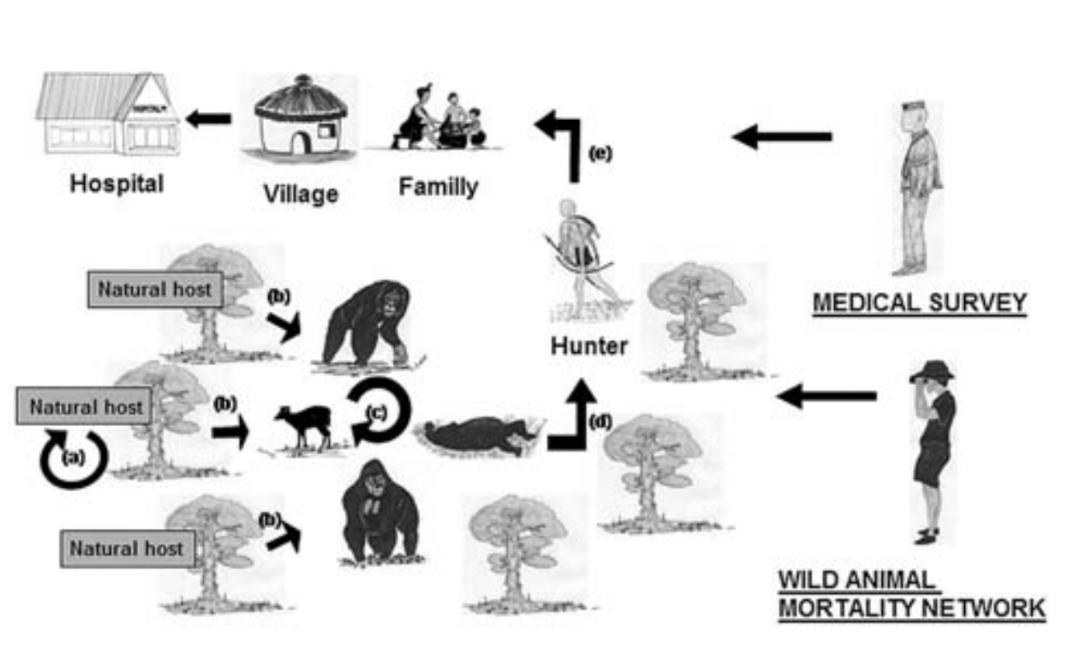6

**Figure 11.** From Rouquet et al., 2005.56 Proposed structure for wildlife mortality surveillance to limit spillover to humans, in concert with medical surveillance. Hunters, who are mostly likely to have wild animal interactions, report carcasses to monitoring teams. Infected hunters may be caught by medical surveillance or may go to infect their families and communities before medical surveillance is effective.

The value of wildlife surveillance as an active component of early warning systems is also increasingly recognized in MVD outbreaks, primarily in a format surrounding routine surveillance of cave-dwelling fruit bat populations such as that implemented by the Rwandan Ministry of Health in response to the 2024 MVD outbreak.59 Institutional multisectoral collaborations for purposeful investigation of zoonotic reservoirs, spillover risks, and integration of One Health principles reflects how the understanding of MVD ecology has grown over time.60

Our findings demonstrate that One Health approaches to filovirus disease surveillance and outbreak prevention hold promise. Encouraging collaboration between wildlife and health sectors could provide early alerts that would be specific to regions and allow a more streamlined, focused approach to outbreak preparedness. To be considered as a compliment to physician/community EBS, One Health surveillance requires more rigorous future research on the operational viability and utility of such systems.

### System Learning and Future Preparedness

In summary, our analysis revealed complexities in the early stages of filovirus outbreaks, as well as evidence of “system learning”. Regions that had cumulative experience of filoviruses had affected subsequent outbreak detection and response capabilities. The success of Uganda’s 2017 MVD outbreak response, in which a medical team rapidly recognized the symptoms of the index case and a family member, was largely attributed to the learning that took place in the period after the 2007 BVD outbreak when “enhanced VHF surveillance and laboratory detection was established”.61 This is illustrative of the long-term commitment of investing in training and capacity building that comes on the heels of successive outbreaks.

Our analysis supported this concept, showing significant overall reduction of the time from an initial report to the time of outbreak declaration (Figures 7 and 8). This improvement has also been noted in country-specific trends in the DRC and Uganda (Figure 9), both countries which have made strides in their surveillance and response capabilities over time, based on experience.62,63 If formalized systems for outbreak reporting, laboratory confirmation, and declaration have advanced over time, then it follows that continued investment in these and policies that support cross-border capacity building are likely to pay off, especially if supported by governments and international entities.64

What our analysis does not clearly quantify, however, is how much system learning is occurring at the initial recognition to outbreak report stage. Because of gaps in early outbreak reporting, it is very difficult to know exactly when the index case(s) became symptomatic, let alone when the primary case(s) became infected. This makes it challenging to determine times between first spillover into humans and index case(s) recognition (no matter the reporting source), which is an important metric for understanding surveillance effectiveness. Reliably measuring this would be extremely beneficial in answering the questions regarding HCW training, surveillance, and preparedness. Anecdotally, it does not seem as though clinicians are increasing their ability to spot these diseases over time— unless they had been involved in a prior outbreak or received training. If this is the case, it serves to illustrate that active HCW engagement with up-to-date training materials at regular intervals will be essential for future preparedness for filovirus outbreak recognition, as early detection heavily depends upon cultivated clinician attentiveness.

In essence, the long-term challenges for filovirus surveillance and preparedness lie in maximizing the chances for prevention and early recognition. Overall improvements to the outbreak preparation and response timeline are evident, and continued investment in this is prudent. However, the true challenge for surveillance will be in using past experiences and hard-learned lessons to find proactive, creative approaches to increase community and health care professional recognition of filovirus outbreaks as early and effectively as possible.

### Limitations

We note the following limitations to our study:

* In primary outbreak epidemiological reports, the information (index and/or first case detection) was largely retrospective. This led to significant gaps in knowledge since the details of the origins of the outbreaks were almost inevitably only partially reconstructed retrospectively, leaving incomplete retellings and subjecting reports that relied on interviews and were susceptible to recall bias. This was particularly true for older outbreaks or outbreaks with large delays in detection (Table 4). As Mmbaga summarizes, outbreak scenarios where many people pass away within days of each other “greatly limited potential investigation of exact movements and exposure risks…”.65
* Our analysis may be subject to publication bias, since only published results were available, generally focusing on larger outbreaks, while smaller outbreaks were not always well-represented in the published literature. We were nevertheless able to at least one report that contained many of our extraction variables for every outbreak, at least partially mitigating this bias.
* Our analysis depended on the screening and data extractions of a single reviewer. While collected information and data were thus subject to a single individual’s interpretation.
* In our statistical analyses, we aimed to identify potential patterns and associations as informatory insights, rather than causal evidence. We acknowledge the inherent limitations of using statistical analysis on historical outbreak reports, which are not designed for these types of comparison, as well as the small sample sizes and heterogeneity which preclude any causal inference.

## Recommendations

Based on our analysis, we offer four major recommendations to enhance surveillance, early detection, and overall preparedness for filoviruses and other high-consequence zoonotic pathogens:

1. **Prioritize and invest in specific and sustainable training for clinicians and HCWs.**

Implementing accessible and sustainable training programs for clinicians can be challenging and setting/context-specific, but our analysis suggests that this will likely be a worthwhile investment if clinician recognition and EBS remain the primary modes of filovirus detection. Training that focuses on maintaining a high index of suspicion for filoviruses, especially when multiple similar cases or clusters arise, should be paramount. Strengthening IPC practices in healthcare environments should also be of central importance. Training should be immediately accessible, scalable, regularly updateable, and deployed in formats suitable for continuous use and professional development, such as in online modules that can be integrated at clinician onboarding, throughout the year, or on an as-needed urgent basis. This recommendation is especially relevant for locations with high personnel turnover.

1. **Strengthen EBS by streamlining internal reporting processes and especially including communities.**

Many countries that experience filovirus outbreaks do not have standardized mechanisms for receiving and rapidly verifying alerts raised from a variety of sources.66 Our analysis shows that detection and reporting processes were not consistent across time or space, and thus outbreak recognition was commonly delayed. Policies that focus on the creation of direct and standardized reporting protocols for physicians and community members should be supported. With this comes the recognition of communities as an invaluable resource and partner in surveillance rather than simply recipients of control measures.

1. **Further explore the utility and viability of One Health supplementary surveillance methods.**

Our analysis demonstrated that there may have been signs of filovirus emergence in animal populations prior to known human spillover. Leveraging these signs for risk communications to the public and alerting HCWs to be on the look-out for clinical cases consistent with filovirus infection could help to enhance surveillance and early detection of human cases. Although current literature provides anecdotal evidence in support of this One Health surveillance approach, further research into its efficacy and cost-benefit, as well as any potential economic and environmental repercussions, is needed.

1. **Continue progress towards laboratory capacity for outbreak recognition.**

Inadequate laboratory capacity was often cited as a key obstacle to the diagnosis of filovirus infection and subsequent outbreak declaration and implementation of IPC and other control measures. While this hurdle appears to have decreased over time,67 continued investment in diagnostic capabilities, both in-country and at the regional level, remains critical for reducing delays in confirmatory testing and spread of filoviruses both in the community and nosocomially. Supporting collaborative efforts to enhance laboratory capacity for pathogen diagnosis through financing for infrastructure development, training, and knowledge sharing will ultimately increase preparedness for filoviruses and other (re)emerging pathogens.

1. **Increase epidemiological focus on the very beginnings of outbreaks.**

In many retrospective outbreak reports, there is consistently a greater focus on control efforts than the beginning of the outbreak, such as the first putative case. Our research highlights the need for more robust documentation efforts from the outset of an outbreak. While often difficult due to retrospective reconstruction and the need for interviews, an understanding of how the time from a first case arising to outbreak declaration has changed over time could greatly inform future planning for outbreak surveillance.

## References

1. Jones KE, Patel NG, Levy MA, Storeygard A, Balk D, Gittleman JL, et al. Global trends in emerging infectious diseases. Nature. 2008 Feb 21;451(7181):990–3.
2. Tahir MJ, Sawal I, Essar MY, Jabbar A, Ullah I, Ahmed A. Disease X: A hidden but inevitable creeping danger. Infect Control Hosp Epidemiol. :1–2.
3. Carlson CJ, Albery GF, Merow C, Trisos CH, Zipfel CM, Eskew EA, et al. Climate change increases cross-species viral transmission risk. Nature. 2022 July;607(7919):555–62.
4. Swanepoel R, Smit SB, Rollin PE, Formenty P, Leman PA, Kemp A, et al. Studies of Reservoir Hosts for Marburg Virus. Emerg Infect Dis. 2007 Dec;13(12):1847–51.
5. Koch LK, Cunze S, Kochmann J, Klimpel S. Bats as putative Zaire ebolavirus reservoir hosts and their habitat suitability in Africa. Sci Rep. 2020 Aug 31;10(1):14268.
6. Broadhurst MJ, Brooks TJG, Pollock NR. Diagnosis of Ebola Virus Disease: Past, Present, and Future. Clin Microbiol Rev. 2016 Oct;29(4):773–93.
7. Dupuy LC, Spiropoulou CF, Towner JS, Spengler JR, Sullivan NJ, Montgomery JM. Filoviruses: Scientific Gaps and Prototype Pathogen Recommendation. J Infect Dis. 2023 Oct 18;228(Suppl 6):S446–59.
8. Slenczka W. Filovirus Research: How it Began. Curr Top Microbiol Immunol. 2017;411:3–21.
9. Breman JG, Heymann DL, Lloyd G, McCormick JB, Miatudila M, Murphy FA, et al. Discovery and Description of Ebola Zaire Virus in 1976 and Relevance to the West African Epidemic During 2013–2016. J Infect Dis. 2016 Oct 15;214(Suppl 3):S93–101.
10. Alexander KA, Sanderson CE, Marathe M, Lewis BL, Rivers CM, Shaman J, et al. What Factors Might Have Led to the Emergence of Ebola in West Africa? PLoS Negl Trop Dis. 2015 June 4;9(6):e0003652.
11. Perkins MD, Kessel M. What Ebola tells us about outbreak diagnostic readiness. Nat Biotechnol. 2015 May;33(5):464–9.
12. World Health Organization. Early detection, assessment and response to acute public health events: implementation of early warning and response with a focus on event-based surveillance. Interim version. Geneva: World Health Organization; 2014. (WHO/HSE/GCR/LYO/2014.4).
13. Beyea SC, Nicoll LH. Writing an integrative review. AORN Journal. 1998 Apr 1;67(4):877–80.
14. Dhollande S, Taylor A, Meyer S, Scott M. Conducting integrative reviews: a guide for novice nursing researchers. J Res Nurs. 2021 Aug;26(5):427–38.
15. Page MJ, McKenzie JE, Bossuyt PM, Boutron I, Hoffmann TC, Mulrow CD, et al. The PRISMA 2020 statement: an updated guideline for reporting systematic reviews. BMJ. 2021 Mar 29;372:n71.
16. CDC. Marburg Virus Disease. 2025 [cited 2025 Aug 29]. History of Marburg Outbreaks. Available from:<https://www.cdc.gov/marburg/outbreaks/index.html>
17. CDC. Ebola. 2025 [cited 2025 Aug 29]. Outbreak History. Available from:<https://www.cdc.gov/ebola/outbreaks/index.html>
18. Methley AM, Campbell S, Chew-Graham C, McNally R, Cheraghi-Sohi S. PICO, PICOS and SPIDER: a comparison study of specificity and sensitivity in three search tools for qualitative systematic reviews. BMC Health Services Research. 2014 Nov 21;14(1):579.
19. Whittemore R, Knafl K. The integrative review: updated methodology. Journal of Advanced Nursing. 2005;52(5):546–53.
20. Popay J, Roberts H, Sowden A, Petticrew M, Arai L, Rodgers M, Britten N, Roen K, Duffy S. Guidance on the conduct of narrative synthesis in systematic reviews. A product from the ESRC methods programme Version. 2006 Apr 1;1(1):b92.
21. Arksey H, O’Malley L. Scoping studies: towards a methodological framework. International Journal of Social Research Methodology. 2005 Feb 1;8(1):19–32.
22. Peters MDJ, Marnie C, Tricco AC, Pollock D, Munn Z, Alexander L, et al. Updated methodological guidance for the conduct of scoping reviews. JBI Evid Synth. 2020 Oct;18(10):2119–26.
23. Thomas J, Harden A. Methods for the thematic synthesis of qualitative research in systematic reviews. BMC Medical Research Methodology. 2008 July 10;8(1):45.
24. Phalkey RK, Yamamoto S, Awate P, Marx M. Challenges with the implementation of an Integrated Disease Surveillance and Response (IDSR) system: systematic review of the lessons learned. Health Policy Plan. 2015 Feb 1;30(1):131–43.
25. Nkoghe D, Kone ML, Yada A, Leroy E. A limited outbreak of Ebola haemorrhagic fever in Etoumbi, Republic of Congo, 2005. Trans R Soc Trop Med Hyg. 2011;105(8):466–72.
26. Towner JS, Pourrut X, Albariño CG, Nkogue CN, Bird BH, Grard G, et al. Marburg Virus Infection Detected in a Common African Bat. Stevenson P, editor. PLoS ONE. 2007 Aug 22;2(8):e764.
27. Bausch DG, Borchert M, Grein T, Roth C, Swanepoel R, Libande ML, et al. Risk Factors for Marburg Hemorrhagic Fever, Democratic Republic of the Congo. Emerg Infect Dis. 2003 Dec;9(12):1531–7.
28. Adjemian J, Farnon EC, Tschioko F, Wamala JF, Byaruhanga E, Bwire GS, et al. Outbreak of Marburg hemorrhagic fever among miners in Kamwenge and Ibanda Districts, Uganda, 2007. J Infect Dis. 2011;204 Suppl 3(ih3, 0413675):S796-9.
29. Bonwitt J, Dawson M, Kandeh M, Ansumana R, Sahr F, Brown H, et al. Unintended consequences of the ‘bushmeat ban’ in West Africa during the 2013–2016 Ebola virus disease epidemic. Social Science & Medicine. 2018 Mar;200:166–73.
30. Marí Saéz A, Weiss S, Nowak K, Lapeyre V, Zimmermann F, Düx A, et al. Investigating the zoonotic origin of the West African Ebola epidemic. EMBO Molecular Medicine. 2015 Jan;7(1):17–23.
31. Smith DH, Johnson BK, Isaacson M, Et Al. EAl. Marburg-virus disease in Kenya. Lancet. 1982;1(Apr. 10):816–20.
32. Muyembe-Tamfum JJ, Kipasa M, Kiyungu C, Colebunders R. Ebola outbreak in Kikwit, Democratic Republic of the Congo: discovery and control measures. J Infect Dis. 1999;179 Suppl 1(ih3, 0413675):S259-62.
33. Aceng J.R., Bosa H.K., Kamara N., Atwine D., Mwebesa H., Nyika H., et al. Continental concerted efforts to control the seventh outbreak of Ebola Virus disease in Uganda: The first 90 days of the response. J Public Health Afr. 2023;14(9):2735.
34. Nachega JB, Mbala-Kingebeni P, Otshudiema J, Mobula LM, Preiser W, Kallay O, et al. Responding to the Challenge of the Dual COVID-19 and Ebola Epidemics in the Democratic Republic of Congo—Priorities for Achieving Control. Am J Trop Med Hyg. 2020 Aug;103(2):597–602.
35. Ngai S, Evers ES, Seoane AKL, Ameh G, Anoko JN, Barnadas C, et al. Outbreak of Marburg virus disease, Equatorial Guinea, 2023. Emerging Infectious Diseases. 2025;31(5):887–95.
36. Outbreak of Ebola haemorrhagic fever in Yambio, south Sudan, April-June 2004. Weekly Epidemiological Record. 2005;80(43):370–5.
37. Nsio J, Kapetshi J, Makiala S, Raymond F, Tshapenda G, Boucher N, et al. 2017 Outbreak of Ebola Virus Disease in Northern Democratic Republic of Congo. J Infect Dis. 2020;221(5):701–6.
38. Kabami Z, Ario AR, Harris JR, Ninsiima M, Ahirirwe SR, Ocero JRA, et al. Ebola disease outbreak caused by the Sudan virus in Uganda, 2022: a descriptive epidemiological study. Uganda Ebola Response Team, editors. Lancet Glob Health. 2024;12(10):e1684–92.
39. Khan AS, Tshioko FK, Heymann DL, Le Guenno B, Nabeth P, Kerstiens B, et al. The reemergence of Ebola hemorrhagic fever, Democratic Republic of the Congo, 1995. Commission de Lutte contre les Epidemies a Kikwit. J Infect Dis. 1999;179 Suppl 1(ih3, 0413675):S76-86.
40. Raab M, Pfadenhauer LM, Millimouno TJ, Hoelscher M, Froeschl G. Knowledge, attitudes and practices towards viral haemorrhagic fevers amongst healthcare workers in urban and rural public healthcare facilities in the N’zérékoré prefecture, Guinea: a cross-sectional study. BMC Public Health. 2020 Mar 6;20(1):296.
41. Epelboin A. Rapport de mission anthropologique sur l’épidémie d’Ebola : Isiro, R. D. Congo, 4 au 30 septembre 2012 [Internet]. OMS; 2012 Nov [cited 2025 July 9] p. 55. Available from:<https://hal.science/hal-01090304>
42. Burke J., Declerq R., Ghysebrechts G. Ebola haemorrhagic fever in Zaire, 1976. Report of an international commission. BULL WHO. 1978;56(2):271 EP – 293.
43. Shoemaker T, MacNeil A, Balinandi S, Campbell S, Wamala JF, McMullan LK, et al. Reemerging Sudan Ebola virus disease in Uganda, 2011. Emerg Infect Dis. 2012;18(9):1480–3.
44. Ndjomou J, Shearrer S, Karlstrand B, Asbun C, Coble J, Alam JS, et al. Sustainable Laboratory Capacity Building After the 2014 Ebola Outbreak in the Republic of Guinea. Front Public Health [Internet]. 2021 June 4 [cited 2025 Aug 26];9. Available from: <https://www.frontiersin.org/journals/public-health/articles/10.3389/fpubh.2021.659504/full>
45. Phan JC, Pettitt J, George JS, Fakoli LS, Taweh FM, Bateman SL, et al. Lateral Flow Immunoassays for Ebola Virus Disease Detection in Liberia. J Infect Dis. 2016 Oct 15;214(Suppl 3):S222–8.
46. Emperador DM, Sayyad L, Brady M, Rowland J, Krapiunaya I, Eckerle I, et al. Laboratory evaluation of antigen rapid diagnostic tests to detect Ebola and Sudan viruses. Journal of Clinical Virology. 2025 Aug 1;179:105830.
47. Lamorde M, Mpimbaza A, Walwema R, Kamya M, Kapisi J, Kajumbula H, et al. A Cross-Cutting Approach to Surveillance and Laboratory Capacity as a Platform to Improve Health Security in Uganda. Health Security. 2018 Dec;16(S1):S-76.
48. Zalwango JF, Naiga HN, Nsubuga EJ, Akunzirwe R, Buhuguru R, Zalwango MG, et al. Understanding the delay in identifying Sudan Virus Disease: gaps in integrated disease surveillance and response and community-based surveillance to detect viral hemorrhagic fever outbreaks in Uganda, September 2022. BMC Infect Dis. 2024;24(1):754.
49. Lamunu M, Lutwama JJ, Kamugisha J, Opio A, Nambooze J, Ndayimirije N, et al. Containing a haemorrhagic fever epidemic: the Ebola experience in Uganda (October 2000-January 2001). Int J Infect Dis. 2004;8(1):27–37.
50. de Vries D.H., Rwemisisi J.T., Musinguzi L.K., Benoni T.E., Muhangi D., de Groot M., et al. The first mile: community experience of outbreak control during an Ebola outbreak in Luwero District, Uganda. BMC Public Health. 2016;16((de Vries) Department of Anthropology, University of Amsterdam, Amsterdam, The Netherlands. d.h.devries@uva.nl):161.
51. Wilkinson A, Fairhead J. Comparison of social resistance to Ebola response in Sierra Leone and Guinea suggests explanations lie in political configurations not culture. Critical Public Health. 2017 Jan 1;27(1):14–27.
52. Tambo E, Ugwu EC, Ngogang JY. Need of surveillance response systems to combat Ebola outbreaks and other emerging infectious diseases in African countries. Infect Dis Poverty. 2014 Aug 5;3(1):29.
53. Groseth A, Feldmann H, Strong JE. The ecology of Ebola virus. Trends Microbiol. 2007 Sept;15(9):408–16.
54. Anonymous. Outbreak(s) of Ebola haemorrhagic fever in the Republic of the Congo, January-April 2003. Wkly Epidemiol Rec. 2003;78(33):285–9.
55. Anonymous. Outbreak(s) of Ebola haemorrhagic fever, Congo and Gabon, October 2001-July 2002. Wkly Epidemiol Rec. 2003;78(26):223–8.
56. Rouquet P, Froment JM, Bermejo M, Kilbourn A, Karesh W, Reed P, et al. Wild animal mortality monitoring and human Ebola outbreaks, Gabon and Republic of Congo, 2001-2003. Emerg Infect Dis. 2005;11(2):283–90.
57. Keatts L, Ondzie A, Perrin M, Cournarie M, Olson S. A wildlife mortality monitoring network that promotes human and wildlife health. One Health Cases. 2023;2023(0027):10-pp.
58. Kuisma E, Olson SH, Cameron KN, Reed PE, Karesh WB, Ondzie AI, et al. Long-term wildlife mortality surveillance in northern Congo: a model for the detection of Ebola virus disease epizootics. Philos Trans R Soc Lond B Biol Sci. 2019;374(1782):20180339.
59. Butera Y, Mutesa L, Parker E, Muvunyi R, Umumararungu E, Ayitewala A, et al. Genomic and transmission dynamics of the 2024 Marburg virus outbreak in Rwanda. Nat Med. 2025;31(2):422–6.
60. Muvunyi CM, Ngabonziza JCS, Bigirimana N, Ndembi N, Siddig EE, Kaseya J, et al. Evidence-Based Guidance for One Health Preparedness, Prevention, and Response Strategies to Marburg Virus Disease Outbreaks. Diseases [Internet]. 2024;12(12). Available from:<https://discover.lshtm.ac.uk/openurl/44HYG/44HYG_services_page?sid=OVID:medline&id=doi:10.3390%2Fdiseases12120309&id=pmid39727639&issn=2079-9721&isbn=&volume=12&issue=12&spage=&pages=&date=2024&title=Diseases&atitle=Evidence-Based+Guidance+for+One+Health+Preparedness%2C+Prevention%2C+and+Response+Strategies+to+Marburg+Virus+Disease+Outbreaks.&aulast=Muvunyi&pid=%3Cauthor%3EMuvunyi+CM%3BNgabonziza+JCS%3BBigirimana+N%3BNdembi+N%3BSiddig+EE%3BKaseya+J%3BAhmed+A%3C%2Fauthor%3E%3CAN%3E39727639%3C%2FAN%3E%3CDT%3EJournal+Article%3C%2FDT%3E>
61. Nyakarahuka L, Shoemaker TR, Balinandi S, Chemos G, Kwesiga B, Mulei S, et al. Marburg virus disease outbreak in Kween District Uganda, 2017: Epidemiological and laboratory findings. PLoS Negl Trop Dis. 2019;13(3):e0007257.
62. Kavulikirwa OK, Sikakulya FK. Recurrent Ebola outbreaks in the eastern Democratic Republic of the Congo: A wake-up call to scale up the integrated disease surveillance and response strategy. One Health. 2022;14(101660501):100379.
63. Shoemaker TR, Balinandi S, Tumusiime A, Nyakarahuka L, Lutwama J, Mbidde E, et al. Impact of enhanced viral haemorrhagic fever surveillance on outbreak detection and response in Uganda. The Lancet Infectious Diseases. 2018 Apr 1;18(4):373–5.
64. Roddy P. A Call to Action to Enhance Filovirus Disease Outbreak Preparedness and Response. Viruses. 2014 Oct;6(10):3699–718.
65. Mmbaga V, Mrema G, Ngenzi D, Magoge W, Mwakapasa E, Jacob F, et al. Epidemiological description of Marburg virus disease outbreak in Kagera region, Northwestern Tanzania. PLoS ONE. 2024;19(9):e0309762.
66. Boland ST, Polich E, Connolly A, Hoar A, Sesay T, Tran AMA. Overcoming Operational Challenges to Ebola Case Investigation in Sierra Leone. Global Health: Science and Practice. 2017 Sept 27;5(3):456–67.
67. Nkengasong JN, Mbopi-Keou FX, Peeling RW, Yao K, Zeh CE, Schneidman M, et al. Laboratory medicine in Africa since 2008: then, now, and the future. The Lancet Infectious Diseases. 2018 Nov 1;18(11):e362–7.

## Appendix

### Appendix A: PRISMA 2020 Checklist

| **Topic** | **No.** | **Item** | **Location where item is reported** |
| --- | --- | --- | --- |
| **TITLE** |  |  |  |
| **Title** | 1 | Identify the report as a systematic review. | Page 5 |
| **ABSTRACT** |  |  |  |
| **Abstract** | 2 | See the PRISMA 2020 for Abstracts checklist |  |
| **INTRODUCTION** |  |  |  |
| **Rationale** | 3 | Describe the rationale for the review in the context of existing knowledge. | Page 11 |
| **Objectives** | 4 | Provide an explicit statement of the objective(s) or question(s) the review addresses. | Pages 11-12 |
| **METHODS** |  |  |  |
| **Eligibility criteria** | 5 | Specify the inclusion and exclusion criteria for the review and how studies were grouped for the syntheses. | Page 15 |
| **Information sources** | 6 | Specify all databases, registers, websites, organisations, reference lists and other sources searched or consulted to identify studies. Specify the date when each source was last searched or consulted. | Page 13 |
| **Search strategy** | 7 | Present the full search strategies for all databases, registers and websites, including any filters and limits used. | Pages 60-63 |
| **Selection process** | 8 | Specify the methods used to decide whether a study met the inclusion criteria of the review, including how many reviewers screened each record and each report retrieved, whether they worked independently, and if applicable, details of automation tools used in the process. | Pages 15-16 |
| **Data collection process** | 9 | Specify the methods used to collect data from reports, including how many reviewers collected data from each report, whether they worked independently, any processes for obtaining or confirming data from study investigators, and if applicable, details of automation tools used in the process. | Pages 16-17 |
| **Data items** | 10a | List and define all outcomes for which data were sought. Specify whether all results that were compatible with each outcome domain in each study were sought (e.g. for all measures, time points, analyses), and if not, the methods used to decide which results to collect. | Pages 16-17 |
|  | 10b | List and define all other variables for which data were sought (e.g. participant and intervention characteristics, funding sources). Describe any assumptions made about any missing or unclear information. | Pages 21-26 |
| **Study risk of bias assessment** | 11 | Specify the methods used to assess risk of bias in the included studies, including details of the tool(s) used, how many reviewers assessed each study and whether they worked independently, and if applicable, details of automation tools used in the process. | Page 16 |
| **Effect measures** | 12 | Specify for each outcome the effect measure(s) (e.g. risk ratio, mean difference) used in the synthesis or presentation of results. | Pages 17-18 |
| **Synthesis methods** | 13a | Describe the processes used to decide which studies were eligible for each synthesis (e.g. tabulating the study intervention characteristics and comparing against the planned groups for each synthesis (item 5)). | N/A |
|  | 13b | Describe any methods required to prepare the data for presentation or synthesis, such as handling of missing summary statistics, or data conversions. | Pages 17-18 |
| 13c | Describe any methods used to tabulate or visually display results of individual studies and syntheses. | Page 18 |
| 13d | Describe any methods used to synthesize results and provide a rationale for the choice(s). If meta-analysis was performed, describe the model(s), method(s) to identify the presence and extent of statistical heterogeneity, and software package(s) used. | Pages 17-18 |
| 13e | Describe any methods used to explore possible causes of heterogeneity among study results (e.g. subgroup analysis, meta-regression). | N/A |
| 13f | Describe any sensitivity analyses conducted to assess robustness of the synthesized results. | N/A |
| **Reporting bias assessment** | 14 | Describe any methods used to assess risk of bias due to missing results in a synthesis (arising from reporting biases). | N/A |
| **Certainty assessment** | 15 | Describe any methods used to assess certainty (or confidence) in the body of evidence for an outcome. | Page 16 |
| **RESULTS** |  |  |  |
| **Study selection** | 16a | Describe the results of the search and selection process, from the number of records identified in the search to the number of studies included in the review, ideally using a flow diagram. | Page 19 |
|  | 16b | Cite studies that might appear to meet the inclusion criteria, but which were excluded, and explain why they were excluded. | N/A |
| **Study characteristics** | 17 | Cite each included study and present its characteristics. | Pages 79-80 |
| **Risk of bias in studies** | 18 | Present assessments of risk of bias for each included study. | N/A |
| **Results of individual studies** | 19 | For all outcomes, present, for each study: (a) summary statistics for each group (where appropriate) and (b) an effect estimate and its precision (e.g. confidence/credible interval), ideally using structured tables or plots. | N/A |
| **Results of syntheses** | 20a | For each synthesis, briefly summarise the characteristics and risk of bias among contributing studies. | N/A |
|  | 20b | Present results of all statistical syntheses conducted. If meta-analysis was done, present for each the summary estimate and its precision (e.g. confidence/credible interval) and measures of statistical heterogeneity. If comparing groups, describe the direction of the effect. | Pages 27-34 |
| 20c | Present results of all investigations of possible causes of heterogeneity among study results. | N/A |
| 20d | Present results of all sensitivity analyses conducted to assess the robustness of the synthesized results. | N/A |
| **Reporting biases** | 21 | Present assessments of risk of bias due to missing results (arising from reporting biases) for each synthesis assessed. | N/A |
| **Certainty of evidence** | 22 | Present assessments of certainty (or confidence) in the body of evidence for each outcome assessed. | Pages 27-34 |
| **DISCUSSION** |  |  |  |
| **Discussion** | 23a | Provide a general interpretation of the results in the context of other evidence. | Pages 35-45 |
|  | 23b | Discuss any limitations of the evidence included in the review. | Page 35 |
| 23c | Discuss any limitations of the review processes used. | Page 35 |
| 23d | Discuss implications of the results for practice, policy, and future research. | Pages 35-44, 46-47 |
| **OTHER INFORMATION** |  |  |  |
| **Registration and protocol** | 24a | Provide registration information for the review, including register name and registration number, or state that the review was not registered. | Page 13 |
|  | 24b | Indicate where the review protocol can be accessed, or state that a protocol was not prepared. | Page 13 |
| 24c | Describe and explain any amendments to information provided at registration or in the protocol. | N/A |
| **Support** | 25 | Describe sources of financial or non-financial support for the review, and the role of the funders or sponsors in the review. | Pages 3-4 |
| **Competing interests** | 26 | Declare any competing interests of review authors. | N/A |
| **Availability of data, code and other materials** | 27 | Report which of the following are publicly available and where they can be found: template data collection forms; data extracted from included studies; data used for all analyses; analytic code; any other materials used in the review. | Page 65 |

*From:* Page MJ, McKenzie JE, Bossuyt PM, Boutron I, Hoffmann TC, Mulrow CD, et al. The PRISMA 2020 statement: an updated guideline for reporting systematic reviews. MetaArXiv. 2020, September 14. DOI: 10.31222/osf.io/v7gm2. For more information, visit: www.prisma-statement.org

### Appendix B: Search Strategies

Search strategies for the five electronic databases searched, created with the aid of an LSHTM librarian.

**Ovid MEDLINE**

**Group 1**

*For all searches, use #1. If searching for Marburg or Ebola outbreaks, use 2 or 3 respectively.*

1 Filoviridae Infections/ or exp Filoviridae/ or filovir*.ti,ab. or Hemorrhagic Fevers, Viral/ 6721

2 Marburgvirus/ or Marburg Virus Disease/ or Marburg.ti,ab.

3 Ebolavirus/ or Hemorrhagic Fever, Ebola/ or Ebola.ti,ab.

**Group 2**

*For all searches, use #8.*

4 Disease Outbreaks/ or outbreak*.ti,ab.

5 epidemic*.ti,ab. or Disease Outbreaks/ or Epidemics/

6 Zoonoses/ or zoono*.ti,ab. or Communicable Diseases, Emerging/

7 Zoonoses/ or spillover*.ti,ab.

8 4 or 5 or 6 or 7

**Group 3**

9 ("index case" or "primary case" or "first case").ti,ab.

10 (early and (signal* or warning* or detection or identification*)).ti,ab.

11 Public Health Surveillance/ or Sentinel Surveillance/ or surveil*.ti,ab.

12 Epidemiology/ or Epidemiological Monitoring/ or Epidemiologic Studies/ or epidemiolog*.ti,ab. or Epidemiologic Methods/

13 9 or 10 or 11 or 12

**Group 4**

14 (physician* or clinician* or "health care worker*" or doctor*).ti,ab.

15 (report* or recogni* or identif* or diagnos*).ti,ab.

16 14 and 15

**Group 5**

*For all searches use #16.*

17 signal*.ti,ab.

18 observation*.ti,ab.

19 recognition*.ti,ab.

20 identification*.ti,ab.

21 sensing.ti,ab.

22 discover*.ti,ab.

23 monitor*.ti,ab.

24 supervision.ti,ab.

25 system*.ti,ab.

26 17 or 18 or 19 or 20 or 21 or 22 or 23 or 24 or 25

**Group 6**

27 Country/Region/Town/Village terms

**Group 7**

28 Year

**Ovid EMBASE**

1 filovir*.ti,ab.

2 exp filoviridae/

3 exp filovirus infection/

4 Marburg.ti,ab. or exp marburgvirus/

5 Ebola.ti,ab. or exp ebolavirus/

6 1 or 2 or 3

7 exp disease outbreak/ or outbreak*.ti,ab.

8 epidemic*.ti,ab. or exp disease outbreak/ or exp epidemic/

9 exp zoonosis/ or zoono*.ti,ab. or exp emerging infection/

10 exp zoonosis/ or spillover*.ti,ab.

11 7 or 8 or 9 or 10

12 ("index case" or "primary case" or "first case").ti,ab.

13 (early and (signal* or warning* or detection or identification*)).ti,ab.

14 exp public health surveillance/ or exp sentinel surveillance/ or surveil*.ti,ab.

15 exp epidemiology/ or exp epidemiologic monitoring/ or exp epidemiologic study/ or exp epidemiologic method/ or epidemiolog*.ti,ab.

16 12 or 13 or 14 or 15

17 (physician* or clinician* or "health care worker*" or doctor*).ti,ab.

18 (report* or recogni* or identif* or diagnos*).ti,ab.

19 17 and 18

20 signal*.ti,ab. or exp signalling/ or exp observation/

21 observation*.ti,ab. or exp observation/

22 recognition*.ti,ab. or exp recognition/

23 identification*.ti,ab. or exp identification/

24 sensing.ti,ab.

25 discover*.ti,ab. or exp discovery/

26 monitor*.ti,ab. 1610692

27 supervision.ti,ab. or exp supervision/ 66885

28 system*.ti,ab. 6647963

Application logic remains the same as original search strategy

**Web of Science**

(TS=(filovir* OR “hemorrhagic fever*” OR marburgvirus OR “marburg virus” OR ebola OR ebolavirus OR “ebola virus”))

AND

(TS=(outbreak* OR epidemic* OR zoono* OR “emerging infection*” OR spillover*))

AND

(

TS=(“index case” OR “primary case” OR “first case”)

OR

TS=(early AND (signal* OR warning* OR detection OR identification*))

OR

TS=(“public health surveillance” OR “sentinel surveillance” OR surveil*)

OR

TS=(epidemiolog* OR “epidemiological monitoring” OR “epidemiologic study” OR “epidemiologic method”)

)

AND

(

TS=(physician* OR clinician* OR “health care worker*” OR doctor*)

AND

TS=(report* OR recogni* OR identif* OR diagnos*)

)

AND

(TS=(signal* OR observation* OR recognition* OR identification* OR sensing OR discover* OR monitor* OR supervision OR system*))

*EXAMPLE: (TS=(filovir* OR “hemorrhagic fever*” OR marburgvirus OR “marburg virus”))*

*AND (TS="1967") AND (TS=(Germany OR Yugoslavia OR Uganda))*

**Ovid Global Health**

1 exp Viral haemorrhagic fevers/

2 exp Ebola haemorrhagic fever/

3 marburg.ti,ab.

4 filovir*.ti,ab.

5 exp Marburg virus disease/ or exp Marburg marburgvirus/

6 ebola.mp. or Ebolavirus.od. or Ebola haemorrhagic fever/

7 Filoviridae Infections/ or exp Filoviridae/ or filovir*.ti,ab. or Hemorrhagic Fevers, Viral/ 9328

8 Marburgvirus/ or Marburg Virus Disease/ or Marburg.ti,ab.

9 Ebolavirus/ or Hemorrhagic Fever, Ebola/ or Ebola.ti,ab.

10 Disease Outbreaks/ or outbreak*.ti,ab.

11 epidemic*.ti,ab. or Disease Outbreaks/ or Epidemics/

12 Zoonoses/ or zoono*.ti,ab. or Communicable Diseases, Emerging/

13 Zoonoses/ or spillover*.ti,ab.

14 10 or 11 or 12 or 13

15 ("index case" or "primary case" or "first case").ti,ab.

16 (early and (signal* or warning* or detection or identification*)).ti,ab.

17 Public Health Surveillance/ or Sentinel Surveillance/ or surveil*.ti,ab.

18 Epidemiology/ or Epidemiological Monitoring/ or Epidemiologic Studies/ or epidemiolog*.ti,ab. or Epidemiologic Methods/

19 15 or 16 or 17 or 18

20 (physician* or clinician* or "health care worker*" or doctor*).ti,ab.

21 (report* or recogni* or identif* or diagnos*).ti,ab.

22 20 and 21

23 signal*.ti,ab.

24 observation*.ti,ab.

25 recognition*.ti,ab.

26 identification*.ti,ab.

27 sensing.ti,ab.

28 discover*.ti,ab.

29 monitor*.ti,ab.

30 supervision.ti,ab.

31 system*.ti,ab.

32 23 or 24 or 25 or 26 or 27 or 28 or 29 or 30 or 31

**Africa-Wide Information**

(Virus) AND (Geographic) AND (Year) AND IF NEEDED (Outbreak/Signal/Surveillance Concepts)

*EXAMPLE: Marburg AND Tanzania AND 2023*

*(yields 6 results)*

### Appendix C: Extraction Form

Standardized extraction form used on all sources.

|  |  |  |  |  |  |  |  |  |  |  |  |  |  |  |  |  |  |  |
| --- | --- | --- | --- | --- | --- | --- | --- | --- | --- | --- | --- | --- | --- | --- | --- | --- | --- | --- |
| **Document Questions** | | | | | **Outbreak Identification** | | | | | | | **Index Case Reporting** | | | | | | |
| Extraction_Date | Document_ID (Virus_AuthorL) | Full_Citation | Document_Type | Document_Language | Outbreak_ID | Virus_Reported | Outbreak_Start_Year | Outbreak_End_Year | Country | Region | Village | Index_Identified? | Index_ID_Date | Index_Case_Def | Index_Case_Demographics | Index_Symptoms | Index_Exposures | Index_Reporting |

|  |  |  |  |  |  |  |  |  |  |  |  |  |  |  |  |  |  |  |  |
| --- | --- | --- | --- | --- | --- | --- | --- | --- | --- | --- | --- | --- | --- | --- | --- | --- | --- | --- | --- |
| **Primary Cases** | | | | | | **Spillover** | | **Healthcare Contact** | | | | | **Reporting** | | | | | | |
| Primary_Case_ID'd? | Primary_ID_Date | Primary_Case_Definition | Primary_Case_Demographics | Primary_Case_Symptoms | Primary_Case_Exposure_History | Known_Spillover? | Spillover_Details | First_Healthcare_Contact | Date_HC_Contact | Intial_Diagnosis | Nosocomial_Spread? | Nosocomial_Spread_Details | Source_Initial_Outbreak_Report | Reported_To | Date_Initial_Outbreak_Report | Outbreak_Declated_Date | Difference(Days) | reporting system = 0, Hospital/physician reported = 1, community health worker =2 | Key_Observations_Signals |

|  |  |  |  |  |  |  |  |  |  |  |  |  |
| --- | --- | --- | --- | --- | --- | --- | --- | --- | --- | --- | --- | --- |
| **Surveillance** | | | | **Outbreak Stats** | | | **One Health** | **Notes** | | | | **Recommendations** |
| Challenges_Early_Detection/Reporting | Existing_VHF_Sruveillance_System_Described? | Surveillance_Methods_Details | Existing_Gaps | Total_Cases_Reported | Totals_Deaths_Reported | CFR_Reported | Notes | Relevant_Quotes | Interpretations | Methods/Limitations | Other_Notes |  |

### 

### Appendix D: Code

R code for statistical analyses and figures three through nine. This code is also publicly available on GitHub at [https://github.com/Early-Signals-and-Surveillance-Challenges-in-Filovirus-Outbreaks/tree/main](https://github.com/feeromerline/Early-Signals-and-Surveillance-Challenges-in-Filovirus-Outbreaks/tree/main).

#################################

###Reporting Source Analysis####

#################################

library(dplyr)

library(ggplot2)

#Decades

dec_vals <- sort(unique(floor(as.integer(df$Start_Year) / 10) * 10))

dec_levels <- paste0(dec_vals, "s")

df <- df %>%

mutate(

Decade = ifelse(is.na(Start_Year), NA_character_,

paste0(floor(as.integer(Start_Year) / 10) * 10, "s")),

Decade = factor(Decade, levels = dec_levels, ordered = TRUE),

# First alert source categories

First_Alert_Source = case_when(

grepl(" and ", Report_Source, ignore.case = TRUE) ~ "Mixed",

grepl("National Epidemic Alert|community|alert", Report_Source, ignore.case = TRUE) ~ "Community/CBS",

grepl("physician|doctor|nurse", Report_Source, ignore.case = TRUE) ~ "Physician/Hospital Staff",

grepl("laboratory|\\bMoH\\b", Report_Source, ignore.case = TRUE) ~ "Formal Indicator",

TRUE ~ "Not Reported"

)

)

head(df)

#N per decade

q_df <- df %>%

filter(!is.na(Decade)) %>%

count(Decade) %>%

rename(n_total = n)

q_df

#Counts

tab <- df %>%

filter(!is.na(Decade)) %>%

count(Decade, First_Alert_Source) %>%

group_by(Decade) %>%

mutate(pct = 100 * n / sum(n)) %>%

ungroup()

#Barchart

ggplot(tab, aes(x = Decade, y = pct, fill = First_Alert_Source)) +

geom_col(color = "white", width = 0.7) +

geom_text(

aes(label = paste0(round(pct, 1), "%")),

position = position_stack(vjust = 0.5),

size = 3,

color = "black"

) +

# add n

geom_text(

data = q_df,

aes(x = Decade, y = 105, label = paste0("n=", n_total)),

inherit.aes = FALSE,

size = 3.2

) +

coord_cartesian(ylim = c(0, 106)) +

labs(x = "Decade", y = "Percent of Outbreaks", fill = "First alert source") +

theme_minimal() +

scale_fill_brewer(palette = "Paired") +

theme(axis.text.x = element_text(angle = 15, hjust = 1))

#Table

tab_src_dec <- with(df, table(Decade, First_Alert_Source, useNA = "no"))

tab_src_dec

round(100 * prop.table(tab_src_dec, 1), 1) # row-wise %

#Fisher's exact

if (all(dim(tab_src_dec) > 1)) {

f_src_dec <- fisher.test(tab_src_dec)

cat(sprintf("\nFisher's exact p = %.4f\n", f_src_dec$p.value))

}

####################################

###Clusters vs Single Index Cases###

####################################

#Basic normalization

trim <- function(x) gsub("^\\s+|\\s+$", "", x)

df$Virus <- trim(df$Virus)

df$Single_or_Cluster <- trim(df$Single_or_Cluster)

df$Days_to_declaration <- trim(df$Days_to_Declaration)

df$Start_Year <- as.integer(df$Start_Year)

#Early Signals

signal <- rep(NA_character_, nrow(df))

signal[grepl("single", df$Single_or_Cluster, ignore.case = TRUE)] <- "Single"

signal[grepl("cluster", df$Single_or_Cluster, ignore.case = TRUE)] <- "Cluster"

df$SignalType <- factor(signal, levels = c("Single", "Cluster"))

# Viruses

virus_group <- rep(NA_character_, nrow(df))

virus_group[grepl("bundib", df$Virus, ignore.case = TRUE)] <- "BDBV"

virus_group[grepl("sudan", df$Virus, ignore.case = TRUE)] <- "SUDV"

virus_group[grepl("zaire", df$Virus, ignore.case = TRUE)] <- "EBOV"

virus_group[grepl("marburg", df$Virus, ignore.case = TRUE)] <- "MARV"

df$VirusGroup <- factor(virus_group,

levels = c("EBOV", "SUDV", "BDBV", "MARV")

)

#Counts for table

tab_signal <- table(df$SignalType, useNA = "no")

tab_signal

#Proportion calc

prop_signal <- prop.table(tab_signal)

round(100 * prop_signal, 1)

#Virus calc

tab_signal_virus <- with(df, table(VirusGroup, SignalType, useNA = "no"))

tab_signal_virus

round(100 * prop.table(tab_signal_virus, 1), 1)

#Summary

props <- df |>

dplyr::filter(!is.na(VirusGroup), !is.na(SignalType)) |>

dplyr::count(VirusGroup, SignalType, name = "n") |>

dplyr::group_by(VirusGroup) |>

dplyr::mutate(pct = n / sum(n),

lbl = paste0(round(pct * 100), "%"))

#N per virus group

n_df <- props |>

dplyr::summarise(n = sum(n), .groups = "drop")

#Plotting

ggplot(props, aes(x = VirusGroup, y = pct, fill = SignalType)) +

geom_col(position = "fill", color = "white", width = 0.7) +

# % labels inside stacks

geom_text(aes(label = lbl),

position = position_fill(vjust = 0.5),

color = "white", size = 3.2) +

# n labels above bars

geom_text(data = n_df,

aes(x = VirusGroup, y = 1.02, label = paste0("n=", n)),

inherit.aes = FALSE, size = 3.2) +

coord_cartesian(ylim = c(0, 1.06)) +

scale_y_continuous(labels = function(x) paste0(x * 100, "%")) +

scale_fill_brewer(palette = "Paired") +

labs(x = "Virus",

y = "Percent of Index Cases",

fill = "First signal" +

theme_minimal(base_size = 11)) +

theme(legend.position = "top",

axis.text.x = element_text(angle = 25, hjust = 1))

#Counts

tab <- with(df, table(VirusGroup, SignalType, useNA = "no"))

tab

round(100 * prop.table(tab, 1), 1)

#Association test

fisher.test(tab)

################################

###Time to Detection Analyses###

################################

library(dplyr)

library(ggplot2)

trim <- function(x) gsub("^\\s+|\\s+$", "", x)

lower <- function(x) tolower(trim(x))

#Establish iqr

iqr_bounds <- function(x) {

q <- quantile(x, probs = c(0.25, 0.5, 0.75), na.rm = TRUE, names = FALSE)

list(p25 = unname(q[1]), med = unname(q[2]), p75 = unname(q[3]))

}

#Re-parse for clarity

parse_days <- function(x) {

x <- lower(x)

if (x %in% c("", "nr", "not declared", "na", "n/a")) return(c(NA_real_, FALSE))

if (grepl("^>\\s*\\d+", x)) {

val <- as.numeric(gsub("[^0-9]", "", x))

return(c(val, TRUE)) # lower bound

}

if (grepl("^[0-9]+$", x)) return(c(as.numeric(x), FALSE))

return(c(NA_real_, FALSE))

}

#Time to declaration

if (!("TimeDecl_days" %in% names(df))) {

parsed <- t(vapply(df$Days_to_Declaration, parse_days, c(NA_real_, FALSE)))

df$TimeDecl_days <- as.numeric(parsed[, 1])

df$TimeDecl_censored <- as.logical(parsed[, 2])

}

#Signal

if (!("SignalType" %in% names(df))) {

sig_raw <- lower(trim(df$Single_or_Cluster))

df$SignalType <- NA_character_

df$SignalType[grepl("single", sig_raw)] <- "Single"

df$SignalType[grepl("cluster", sig_raw)] <- "Cluster"

df$SignalType <- factor(df$SignalType, levels = c("Single","Cluster"))

}

# Virus

if (!("VirusGroup" %in% names(df))) {

v <- lower(trim(df$Virus))

df$VirusGroup <- dplyr::case_when(

grepl("bundib|bdbv", v) ~ "BDBV",

grepl("sudan|sudv", v) ~ "SUDV",

grepl("zaire", v) ~ "EBOV",

grepl("\\bebov\\b|ebola( virus disease)?$", v) ~ "EBOV",

grepl("marburg|marv",v) ~ "MARV",

TRUE ~ NA_character_

)

df$VirusGroup <- factor(df$VirusGroup, levels = c("EBOV","SUDV","BDBV","MARV"))

}

#HCW infections

col_hcw <- names(df)[grepl("health.*worker.*infect", tolower(names(df)))]

if (length(col_hcw) != 1) {

stop("Couldn't uniquely identify the HCW infections column. Found: ",

paste(col_hcw, collapse = ", "))

}

hcw_raw <- lower(trim(df[[col_hcw]]))

df$HCW_YN <- dplyr::case_when(

hcw_raw %in% c("y","yes","1") ~ "Yes",

hcw_raw %in% c("n","no","0") ~ "No",

hcw_raw %in% c("", "nr", "not reported", "na", "n/a") ~ NA_character_,

TRUE ~ NA_character_

)

df$HCW_YN <- factor(df$HCW_YN, levels = c("No","Yes"))

#Time to declaration

sub_hcw <- df %>%

filter(!is.na(TimeDecl_days), !is.na(HCW_YN))

n_hcw <- sub_hcw %>% count(HCW_YN, name = "n")

stats_hcw <- sub_hcw %>%

group_by(HCW_YN) %>%

summarise(

n = n(),

p25 = quantile(TimeDecl_days, 0.25),

med = median(TimeDecl_days),

p75 = quantile(TimeDecl_days, 0.75),

.groups = "drop"

)

test_hcw <- wilcox.test(TimeDecl_days ~ HCW_YN, data = sub_hcw, exact = FALSE)

cat("\n--- Time to declaration by HCW infections ---\n")

print(stats_hcw)

cat(sprintf("Mann–Whitney (Wilcoxon rank-sum) p = %.4f\n", test_hcw$p.value))

#Figure 5: Boxplot HCW infections vs Time to Declaration

x_labs_hcw <- sub_hcw %>% count(HCW_YN) %>%

mutate(lab = paste0(HCW_YN, " (n=", n, ")")) %>%

as.data.frame()

p_hcw <- ggplot(sub_hcw, aes(HCW_YN, TimeDecl_days, fill = HCW_YN)) +

geom_boxplot(width = 0.65, alpha = 0.75, outlier.alpha = 0.3, color = "black") +

geom_jitter(aes(shape = VirusGroup), width = 0.15, height = 0, size = 2.2,

alpha = 0.7, color = "black") +

scale_fill_manual(values = c("No"="#afd1e7","Yes"="#f6f364"), guide = "none") +

scale_shape_manual(values = c(21,24,22,23), name = "Virus") +

scale_x_discrete(labels = setNames(x_labs_hcw$lab, x_labs_hcw$HCW_YN)) +

labs(x = "HCW infections",

y = "Days from earliest report to official declaration") +

theme_minimal(base_size = 11) +

theme(axis.text.x = element_text(angle = 15, hjust = 1),

legend.position = "bottom")

p_hcw

ggsave("fig6_time_by_HCW.png", p_hcw, width = 6, height = 4, dpi = 300)

#Figure 6: Cluster or Single vs Time to Declaration

sub_sig <- df %>%

filter(!is.na(TimeDecl_days), !is.na(SignalType))

stats_sig <- sub_sig %>%

group_by(SignalType) %>%

summarise(

n = n(),

p25 = quantile(TimeDecl_days, 0.25),

med = median(TimeDecl_days),

p75 = quantile(TimeDecl_days, 0.75),

.groups = "drop"

)

test_sig <- wilcox.test(TimeDecl_days ~ SignalType, data = sub_sig, exact = FALSE)

cat("\n--- Time to declaration: Single vs Cluster ---\n")

print(stats_sig)

cat(sprintf("Mann–Whitney (Wilcoxon rank-sum) p = %.4f\n", test_sig$p.value))

#Boxplot

x_labs_sig <- sub_sig %>% count(SignalType) %>%

mutate(lab = paste0(SignalType, " (n=", n, ")")) %>%

as.data.frame()

p_sig <- ggplot(sub_sig, aes(SignalType, TimeDecl_days, fill = SignalType)) +

geom_boxplot(width = 0.65, alpha = 0.75, outlier.alpha = 0.3, color = "black") +

geom_jitter(aes(shape = VirusGroup), width = 0.15, height = 0, size = 2.2,

alpha = 0.7, color = "black") +

scale_fill_manual(values = c("Single"="#b2df8a","Cluster"="#08306b"), guide = "none") +

scale_shape_manual(values = c(21,24,22,23), name = "Virus") +

scale_x_discrete(labels = setNames(x_labs_sig$lab, x_labs_sig$SignalType)) +

labs(x = "First signal type",

y = "Days from earliest report to official declaration") +

theme_minimal(base_size = 11) +

theme(axis.text.x = element_text(angle = 15, hjust = 1),

legend.position = "bottom")

p_sig

ggsave("fig7_time_by_signal.png", p_sig, width = 6, height = 4, dpi = 300)

fmt <- function(med, p25, p75) sprintf("%g (IQR %g–%g)", med, p25, p75)

######################################

###Time to Detection Across Decades###

######################################

#Subset

sub_dec <- df %>%

filter(!is.na(TimeDecl_days), !is.na(Decade))

#N per decade

x_labs_dec <- sub_dec %>%

count(Decade) %>%

mutate(lab = paste0(as.character(Decade), " (n=", n, ")")) %>%

as.data.frame()

#Style

shape_map <- c("EBOV" = 21, "SUDV" = 24, "BDBV" = 22, "MARV" = 23)

#Colors

dec_levels <- levels(sub_dec$Decade)

color_map <- setNames(

colorRampPalette(c("#C1E1C1", "#b2df8a", "#6B8E23", "#228B22"))(length(dec_levels)),

dec_levels

)

p_dec <- ggplot(sub_dec, aes(Decade, TimeDecl_days, fill = Decade)) +

geom_boxplot(width = 0.65, alpha = 0.85, outlier.alpha = 0.3, color = "black") +

#shapes by virus, black outline, no color fill

geom_jitter(aes(shape = VirusGroup),

width = 0.12, height = 0, size = 2.2,

alpha = 0.7, color = "black", show.legend = TRUE) +

scale_fill_manual(values = color_map, guide = "none") +

scale_shape_manual(values = shape_map, name = "Virus") +

scale_x_discrete(labels = setNames(x_labs_dec$lab, x_labs_dec$Decade)) +

labs(x = "Decade",

y = "Days from earliest report to official declaration") +

theme_minimal(base_size = 11) +

theme(axis.text.x = element_text(angle = 15, hjust = 1),

legend.position = "bottom")

p_dec

#Medians & IQR

stats_dec <- sub_dec %>%

group_by(Decade) %>%

summarise(

n = n(),

p25 = quantile(TimeDecl_days, 0.25),

med = median(TimeDecl_days),

p75 = quantile(TimeDecl_days, 0.75),

.groups = "drop"

)

cat("\n--- Time to declaration by decade ---\n")

print(stats_dec)

#Kruskal–Wallis

kw_dec <- kruskal.test(TimeDecl_days ~ Decade, data = sub_dec)

cat(sprintf("Kruskal–Wallis: chi^2 = %.3f, df = %d, p = %.4f\n",

kw_dec$statistic, kw_dec$parameter, kw_dec$p.value))

####Overall trend graphs#####

#Cleanup

df$Virus <- trim(df$Virus)

df$VirusGroup <- dplyr::case_when(

grepl("bundib|bdbv", tolower(df$Virus)) ~ "BDBV",

grepl("sudan|sudv", tolower(df$Virus)) ~ "SUDV",

grepl("zaire", tolower(df$Virus)) ~ "EBOV",

grepl("\\bebov\\b|ebola( virus disease)?$", tolower(df$Virus)) ~ "EBOV",

grepl("marburg|marv",tolower(df$Virus)) ~ "MARV",

TRUE ~ NA_character_

)

df$VirusGroup <- factor(df$VirusGroup, levels = c("EBOV","SUDV","BDBV","MARV"))

#Parse days

parse_days <- function(x) {

x <- tolower(trim(x))

if (x %in% c("", "nr", "not declared", "na", "n/a")) return(c(NA_real_, FALSE))

if (grepl("^>\\s*\\d+", x)) {

val <- as.numeric(gsub("[^0-9]", "", x))

return(c(val, TRUE))

}

if (grepl("^[0-9]+$", x)) return(c(as.numeric(x), FALSE))

return(c(NA_real_, FALSE))

}

parsed <- t(vapply(df$Days_to_Declaration, parse_days, c(NA_real_, FALSE)))

df$TimeDecl_days <- as.numeric(parsed[, 1])

df$TimeDecl_censored <- as.logical(parsed[, 2])

#Cleanup

df$Country <- trim(df$Country)

df$Virus <- trim(df$Virus)

df$VirusGroup <- factor(df$VirusGroup,

levels = c("EBOV", "SUDV", "BDBV", "MARV")

)

#Plotting

plotdf <- df %>%

dplyr::filter(!is.na(Start_Year),

!is.na(TimeDecl_days),

!is.na(VirusGroup),

!is.na(Country))

plotdf$Country <- dplyr::recode(plotdf$Country,

"The Republic of the Congo" = "Republic of the Congo",

"Guinea/West Africa" = "Guinea"

)

shape_map <- c("EBOV"=16, "SUDV"=17, "BDBV"=15, "MARV"=18)

color_map <- c("EBOV"="#afd1e7", "SUDV"="#08306b",

"BDBV"="#f7fbff", "MARV"="#f6f364")

#Country limiter

keepers <- plotdf %>% dplyr::count(Country) %>% dplyr::filter(n >= 2) %>% dplyr::arrange(dplyr::desc(n)) %>% dplyr::pull(Country)

facetdf <- plotdf %>% dplyr::filter(Country %in% keepers)

facetdf$Country <- factor(facetdf$Country, levels = keepers)

topN <- 2

top_countries <- plotdf %>% count(Country, sort = TRUE) %>% slice_head(n = topN) %>% pull(Country)

facetdf2 <- plotdf %>% filter(Country %in% top_countries)

p_country <- ggplot(facetdf2, aes(Start_Year, TimeDecl_days)) +

# overall (all viruses) per-country trend

geom_smooth(aes(group = 1), method = "lm", se = FALSE,

color = "grey55", linetype = "dashed", linewidth = 0.7) +

# black outline for points (slightly larger, underneath)

geom_point(

aes(shape = VirusGroup),

color = "black",

size = 3.5,

alpha = 0.9

) +

# virus-specific points and trends

geom_point(aes(shape = VirusGroup, color = VirusGroup),

size = 3, alpha = 0.9) +

scale_shape_manual(values = shape_map, name = "Virus") +

scale_color_manual(values = color_map, name = "Virus") +

labs(x = "Outbreak start year",

y = "Days from earliest report to official declaration") +

theme_minimal(base_size = 11) +

theme(axis.text.x = element_text(angle = 25, hjust = 1),

legend.position = "bottom") +

facet_wrap(~ Country, ncol = 4)

p_country

#Shapes

shape_map <- c("EBOV" = 21, # circle

"SUDV" = 24, # triangle

"BDBV" = 22, # square

"MARV" = 23) # diamond

color_map <- c("EBOV"= "#afd1e7", "SUDV"="#08306b",

"BDBV"="#f7fbff", "MARV"="#f6f364")

p_overall <- ggplot(plotdf, aes(Start_Year, TimeDecl_days)) +

# black outline for points

geom_point(

aes(shape = VirusGroup, fill = VirusGroup),

color = "black", # outline

size = 3, alpha = 0.9) +

# global solid trend (all outbreaks)

geom_smooth(method = "lm", se = FALSE, color = "black", linewidth = 1) +

# colored dashed lines by virus

geom_smooth(

aes(color = VirusGroup, group = VirusGroup),

method = "lm", se = FALSE,

linetype = "dashed", linewidth = 0.9) +

# manual scales (only once each!)

scale_shape_manual(values = shape_map, name = "Virus") +

scale_fill_manual(values = color_map, name = "Virus") +

scale_color_manual(values = color_map, name = "Virus") +

labs(

x = "Outbreak start year",

y = "Days from earliest report to official declaration") +

theme_minimal(base_size = 11) +

theme(

axis.text.x = element_text(angle = 25, hjust = 1),

legend.position = "bottom")

p_overall

#########################

###Additional Analyses###

#########################

trim <- function(x) gsub("^\\s+|\\s+$", "", x)

lower <- function(x) tolower(trim(x))

col_signal <- names(df)[grepl("single|cluster", tolower(names(df)))]

col_sex <- names(df)[grepl("^sex$", tolower(names(df)))]

col_hemo <- names(df)[grepl("haem|hemorr", tolower(names(df)))]

col_expo <- names(df)[grepl("exposure", tolower(names(df)))]

if (length(col_signal) != 1) stop("Couldn't uniquely identify 'Single or Cluster' column")

if (length(col_sex) != 1) stop("Couldn't uniquely identify 'Sex' column")

if (length(col_hemo) != 1) stop("Couldn't uniquely identify 'With haemorrhage' column")

if (length(col_expo) != 1) stop("Couldn't uniquely identify 'Exposure known' column")

#Cleanup

df$Signal_raw <- lower(df[[col_signal]])

df$Sex_raw <- lower(df[[col_sex]])

df$Hemo_raw <- lower(df[[col_hemo]])

df$Expo_raw <- lower(df[[col_expo]])

#Standardize

df$SignalType <- dplyr::case_when(

grepl("single", df$Signal_raw) ~ "Single",

grepl("cluster", df$Signal_raw) ~ "Cluster",

df$Signal_raw %in% c("", "NR", "Not Reported", "NA", "N/A") ~ "NR",

TRUE ~ "NR"

)

# 1) Index case sex

df$Sex_cat <- dplyr::case_when(

df$SignalType != "Single" ~ "Not applicable",

df$Sex_raw %in% c("", "NR", "not reported") ~ "Not reported",

grepl("^m", df$Sex_raw) ~ "Male",

grepl("^f", df$Sex_raw) ~ "Female",

df$Sex_raw %in% c("na", "N/A") ~ "Not applicable",

TRUE ~ "Other/unspecified"

)

sex_counts <- df %>%

count(Sex_cat, name = "n") %>%

mutate(pct = round(100 * n / sum(n), 1)) %>%

arrange(match(Sex_cat,

c("Male", "Female", "Other/unspecified",

"Not reported", "Not applicable")))

print(sex_counts)

#By Virus

df$VirusGroup <- dplyr::case_when(

grepl("bundib", tolower(df$Virus)) ~ "EBOV-BDBV",

grepl("sudan", tolower(df$Virus)) ~ "EBOV-SUDV",

grepl("zaire", tolower(df$Virus)) ~ "EBOV-Zaire",

grepl("marburg",tolower(df$Virus)) ~ "MARV",

TRUE ~ "Other/NR"

)

df %>% count(VirusGroup, Sex_cat) %>%

group_by(VirusGroup) %>%

mutate(pct = round(100 * n / sum(n), 1)) %>%

arrange(VirusGroup, desc(n)) %>% print(n = 100)

#Exposure known

df$Expo_cat <- dplyr::case_when(

df$Expo_raw %in% c("", "nr", "not reported", "na", "n/a") ~ "Not reported or Cluster with unknown exposure",

grepl("^y", df$Expo_raw) ~ "Yes",

grepl("^n", df$Expo_raw) ~ "No",

TRUE ~ "Not reported or Cluster with unknown exposure"

)

expo_counts <- df %>%

count(Expo_cat, name = "n") %>%

mutate(pct = round(100 * n / sum(n), 1)) %>%

arrange(match(Expo_cat,

c("Yes", "No", "Not reported or Cluster with unknown exposure")))

print(expo_counts)

# 3) With haemorrhage?

df$Hemo_cat <- dplyr::case_when(

df$Hemo_raw %in% c("", "nr", "not reported") ~ "Not reported",

grepl("^y|^yes", df$Hemo_raw) ~ "Yes",

grepl("^n|^no", df$Hemo_raw) ~ "No",

df$Hemo_raw %in% c("na", "n/a") ~ "Not applicable",

TRUE ~ "Not reported"

)

hemo_counts <- df %>%

count(Hemo_cat, name = "n") %>%

mutate(pct = round(100 * n / sum(n), 1)) %>%

arrange(match(Hemo_cat,

c("Yes", "No", "Not reported", "Not applicable")))

print(hemo_count)

### Appendix E: Bibliography

Bibliography of all 99 reports that underwent data extraction. Bibliography generated in Zotero software.

Absolomon G, Brent CR, Nyabyenda EC, Mwiza K, Irakiza P, Chiwandire Z, et al. Marburg virus disease in Rwanda: an observational study of the first 10 days of outbreak response, clinical interventions, and outcomes. BMC Med. 2025;23(1):292.

Aceng J.R., Bosa H.K., Kamara N., Atwine D., Mwebesa H., Nyika H., et al. Continental concerted efforts to control the seventh outbreak of Ebola Virus disease in Uganda: The first 90 days of the response. J Public Health Afr. 2023;14(9):2735.

Adjemian J, Farnon EC, Tschioko F, Wamala JF, Byaruhanga E, Bwire GS, et al. Outbreak of Marburg hemorrhagic fever among miners in Kamwenge and Ibanda Districts, Uganda, 2007. J Infect Dis. 2011;204 Suppl 3(ih3, 0413675):S796-9.

Ahuka-Mundeke S, Ahmed Y, Allarangar Y, Anoko J, Archer B, Abedi A, et al. Outbreak of Ebola virus disease in the Democratic Republic of the Congo, April-May, 2018: an epidemiological study. LANCET. 2018 July 21;392(10143):213–21.

Al-Tammemi AB, Sallam M, Rebhi A, Soliman L, Al Sarayrih L, Tarhini Z, et al. The outbreak of Ebola virus disease in 2022: A spotlight on a re-emerging global health menace. Narra J. 2022;2(3):e97.

Amblard J, Obiang P, Edzang S, Prehaud C, Bouloy M, Guenno BL. Identification of the Ebola virus in Gabon in 1994. Lancet. 1997;349(9046):181–2.

Anonymous. From the Centers for Disease Control and Prevention. Outbreak of Ebola viral hemorrhagic fever--Zaire, 1995. JAMA. 1995;273(22):1747–8.

Anonymous. Outbreak(s) of Ebola haemorrhagic fever in the Republic of the Congo, January-April 2003. Wkly Epidemiol Rec. 2003;78(33):285–9.

Anonymous. Outbreak(s) of Ebola haemorrhagic fever, Congo and Gabon, October 2001-July 2002. Wkly Epidemiol Rec. 2003;78(26):223–8.

Anonymous. Outbreak of Marburg haemorrhagic fever: Uganda, June-August 2007. Wkly Epidemiol Rec. 2007;82(43):381–4.

Baize S, Pannetier D, Oestereich L, Rieger T, Koivogui L, Magassouba N, et al. Emergence of Zaire Ebola virus disease in Guinea. N Engl J Med. 2014;371(15):1418–25.

Baron R.C., McCormick J.B., Zubeir O.A. Ebola virus disease in southern Sudan: Hospital dissemination and intrafamilial spread. BULL WHO. 1983;61(6):997 EP – 1003.

Bausch DG, Borchert M, Grein T, Roth C, Swanepoel R, Libande ML, et al. Risk Factors for Marburg Hemorrhagic Fever, Democratic Republic of the Congo. Emerg Infect Dis. 2003 Dec;9(12):1531–7.

Borchert M, Mutyaba I, Van Kerkhove M, Lutwama J, Luwaga H, Bisoborwa G, et al. Ebola haemorrhagic fever outbreak in Masindi District, Uganda: outbreak description and lessons learned. BMC INFECTIOUS DISEASES. 2011 Dec 28;11.

Breman JG, Heymann DL, Lloyd G, McCormick JB, Miatudila M, Murphy FA, et al. Discovery and Description of Ebola Zaire Virus in 1976 and Relevance to the West African Epidemic During 2013–2016. J Infect Dis. 2016 Oct 15;214(Suppl 3):S93–101.

Bres P. The epidemic of Ebola haemorrhagic fever in Sudan and Zaire, 1976: Introductory note. BULL WHO. 1978;56(2):245.

Burke J., Declerq R., Ghysebrechts G. Ebola haemorrhagic fever in Zaire, 1976. Report of an international commission. BULL WHO. 1978;56(2):271 EP – 293.

Butera Y, Mutesa L, Parker E, Muvunyi R, Umumararungu E, Ayitewala A, et al. Genomic and transmission dynamics of the 2024 Marburg virus outbreak in Rwanda. Nat Med. 2025;31(2):422–6.

Bwire G., Sartorius B., Guerin P., Tegegne M.A., Okware S.I., Talisuna A.O. Sudan Ebola virus (SUDV) outbreak in Uganda, 2022: lessons learnt and future priorities for sub-Saharan Africa. BMC Med. 2023;21(1):144.

CDC. Brief report: Outbreak of Marburg virus hemorrhagic fever - Angola, October 1, 2004-March 29, 2005 (Reprinted from MMWR, vol 54, pg 308-309, 2005). JAMA-JOURNAL OF THE AMERICAN MEDICAL ASSOCIATION. 2005 May 18;293(19):2336–2336.

Changula K., Kajihara M., Mweene A.S., Takada A. Ebola and Marburg virus diseases in Africa: Increased risk of outbreaks in previously unaffected areas? Microbiol Immunol. 2014;58(9):483 EP – 491.

de Vries D.H., Rwemisisi J.T., Musinguzi L.K., Benoni T.E., Muhangi D., de Groot M., et al. The first mile: community experience of outbreak control during an Ebola outbreak in Luwero District, Uganda. BMC Public Health. 2016;16((de Vries) Department of Anthropology, University of Amsterdam, Amsterdam, The Netherlands. d.h.devries@uva.nl):161.

Deng I.M., Duku O., Gillo A.L. Ebola haemorrhagic fever in Sudan, 1976. Report of a WHO/International Study Team. BULL WHO. 1978;56(2):247 EP – 270.

Edward M, Scott GY, John W, Rajabu ME, Mahulu E, Saidu Musa S, et al. Marburg virus outbreak in Tanzania: A threat to global health security. Public Health Chall. 2023;2(4):e140.

Epelboin A. Rapport de mission anthropologique sur l’épidémie d’Ebola : Isiro, R. D. Congo, 4 au 30 septembre 2012 [Internet]. OMS; 2012 Nov [cited 2025 July 9] p. 55. Available from:<https://hal.science/hal-01090304>

European Centre for Disease Prevention and Control. Ebola virus disease outbreak in North Kivu, Democratic Republic of the Congo, 2021 – 22 February 2021. Stockholm: ECDC; 2021. 7 p. Available from:<https://www.ecdc.europa.eu/>

Formenty P, Libama F, Epelboin A, Allarangar Y, Leroy E, Moudzeo H, et al. [Outbreak of Ebola hemorrhagic fever in the Republic of the Congo, 2003: a new strategy?]. Med Trop (Mars). 2003;63(3):291–5.

Fortes F., Da Conceicao A.V., Centeno-Lima S., Do Rosario V.E., Bernardino L., Folo P., et al. The control of an epidemic outbreak of Marburg hemorrhagic fever in Angola, 2004-2005. Enferm Emergentes. 2007;9(1):31 EP – 33.

Gatherer D. The 2014 Ebola virus disease outbreak in West Africa. Journal of General Virology. 2014 Aug 1;95(8):1619–24.

Georges AJ, Leroy EM, Renaut AA, Benissan CT, Nabias RJ, Ngoc MT, et al. Ebola hemorrhagic fever outbreaks in Gabon, 1994-1997: epidemiologic and health control issues. J Infect Dis. 1999;179 Suppl 1(ih3, 0413675):S65-75.

Grimes KEL, Ngoyi BF, Stolka KB, Hemingway-Foday JJ, Lubula L, Mossoko M, et al. Contextual, Social and Epidemiological Characteristics of the Ebola Virus Disease Outbreak in Likati Health Zone, Democratic Republic of the Congo, 2017. Front public health. 2020;8(101616579):349.

Grobusch MP, Jokelainen P, Wyllie AL, Gupta N, Pano-Pardo JR, Barac A, et al. Marburg virus disease outbreak in Rwanda, 2024. Clin Microbiol Infect. 2025;31(2):161–3.

Harris E. WHO: Marburg Virus Outbreak Confirmed in Equatorial Guinea. JAMA. 2023;329(12):969.

Hemingway-Foday JJ, Ngoyi BF, Tunda C, Stolka KB, Grimes KEL, Lubula L, et al. Lessons Learned from Reinforcing Epidemiologic Surveillance During the 2017 Ebola Outbreak in the Likati District, Democratic Republic of the Congo. Health Secur. 2020;18(S1):S81–91.

Heymann D.L., Weisfeld J.S., Webb P.A. Ebola hemorrhagic fever: Tandala, Zaire, 1977-1978. J INFECT DIS. 1980;142(3):372 EP – 376.

Hulseberg CE, Kumar R, Di Paola N, Larson P, Nagle ER, Richardson J, et al. Molecular analysis of the 2012 Bundibugyo virus disease outbreak. Cell Rep Med. 2021;2(8):100351.

Ilunga Kalenga O, Moeti M, Sparrow A, Nguyen VK, Lucey D, Ghebreyesus TA. The Ongoing Ebola Epidemic in the Democratic Republic of Congo, 2018-2019. N Engl J Med. 2019;381(4):373–83.

Johnson E.D., Johnson B.K., Silverstein D., Tukei P., Geisbert T.W., Sanchez A.N., et al. Characterization of a new Marburg virus isolated from a 1987 fatal case in Kenya. Arch Virol Suppl. 1996;11((Johnson, Johnson, Silverstein, Tukei, Geisbert, Sanchez, Jahrling) United States Army Medical Research Institute of Infectious Diseases, Fort Detrick, Frederick, Maryland 21702-5011, USA.):101 EP – 114.

Kabami Z, Ario AR, Harris JR, Ninsiima M, Ahirirwe SR, Ocero JRA, et al. Ebola disease outbreak caused by the Sudan virus in Uganda, 2022: a descriptive epidemiological study. Uganda Ebola Response Team, editors. Lancet Glob Health. 2024;12(10):e1684–92.

Keita AK, Koundouno FR, Faye M, Dux A, Hinzmann J, Diallo H, et al. Resurgence of Ebola virus in 2021 in Guinea suggests a new paradigm for outbreaks. Nature. 2021;597(7877):539–43.

Keita M, Talisuna A, Chamla D, Burmen B, Cherif MS, Polonsky JA, et al. Investing in preparedness for rapid detection and control of epidemics: analysis of health system reforms and their effect on 2021 Ebola virus disease epidemic response in Guinea. BMJ glob health [Internet]. 2023;8(1). Available from:<https://discover.lshtm.ac.uk/openurl/44HYG/44HYG_services_page?sid=OVID:medline&id=doi:10.1136%2Fbmjgh-2022-010984&id=pmid36599498&issn=2059-7908&isbn=&volume=8&issue=1&spage=&pages=&date=2023&title=BMJ+Global+Health&atitle=Investing+in+preparedness+for+rapid+detection+and+control+of+epidemics%3A+analysis+of+health+system+reforms+and+their+effect+on+2021+Ebola+virus+disease+epidemic+response+in+Guinea.&aulast=Keita&pid=%3Cauthor%3EKeita+M%3BTalisuna+A%3BChamla+D%3BBurmen+B%3BCherif+MS%3BPolonsky+JA%3BBoland+S%3BBarry+B%3BMesfin+S%3BTraore+FA%3BTraore+J%3BKimenyi+JP%3BDiallo+AB%3BGodjedo+TP%3BTraore+T%3BDelamou+A%3BKi-Zerbo+GA%3BDagron+S%3BKeiser+O%3BGueye+AS%3C%2Fauthor%3E%3CAN%3E36599498%3C%2FAN%3E%3CDT%3EJournal+Article%3C%2FDT%3E>

Khan AS, Tshioko FK, Heymann DL, Le Guenno B, Nabeth P, Kerstiens B, et al. The reemergence of Ebola hemorrhagic fever, Democratic Republic of the Congo, 1995. Commission de Lutte contre les Epidemies a Kikwit. J Infect Dis. 1999;179 Suppl 1(ih3, 0413675):S76-86.

Kiggundu T., Ario A.R., Kadobera D., Kwesiga B., Migisha R., Makumbi I., et al. Notes from the Field: Outbreak of Ebola Virus Disease Caused by Sudan ebolavirus - Uganda, August-October 2022. MMWR Morb Mortal Wkly Rep. 2022;71(45):1457 EP – 1459.

Kinganda-Lusamaki E, Whitmer S, Lokilo-Lofiko E, Amuri-Aziza A, Muyembe-Mawete F, Makangara-Cigolo JC, et al. 2020 Ebola virus disease outbreak in Equateur Province, Democratic Republic of the Congo: a retrospective genomic characterisation. Lancet Microbe. 2024;5(2):e109–18.

Knust B, Schafer IJ, Wamala J, Nyakarahuka L, Okot C, Shoemaker T, et al. Multidistrict Outbreak of Marburg Virus Disease-Uganda, 2012. J Infect Dis. 2015;212 Suppl 2(ih3, 0413675):S119-28.

Kratz T, Roddy P, Tshomba Oloma A, Jeffs B, Pou Ciruelo D, de la Rosa O, et al. Ebola Virus Disease Outbreak in Isiro, Democratic Republic of the Congo, 2012: Signs and Symptoms, Management and Outcomes. PLoS ONE. 2015;10(6):e0129333.

Lamunu M, Lutwama JJ, Kamugisha J, Opio A, Nambooze J, Ndayimirije N, et al. Containing a haemorrhagic fever epidemic: the Ebola experience in Uganda (October 2000-January 2001). Int J Infect Dis. 2004;8(1):27–37.

Leroy EM, Souquiere S, Rouquet P, Drevet D. Re-emergence of ebola haemorrhagic fever in Gabon. Lancet (British edition). 2002;359(9307):712.

Leroy EM, Epelboin A, Mondonge V, Pourrut X, Gonzalez JP, Muyembe-Tamfum JJ, et al. Human Ebola outbreak resulting from direct exposure to fruit bats in Luebo, Democratic Republic of Congo, 2007. Vector borne zoonotic dis. 2009;9(6):723–8.

Lusamaki EK, Pratt CB, Mukadi DB, Whitmer S et al, Amuri A et al. NEW CONFIRMED EBOLA OUTBREAK IN NORD KIVU, DEMOCRATIC REPUBLIC OF CONGO, FEBRUARY 2021. American Journal of Tropical Medicine and Hygiene. 2021 Jan 1;105(5 Supp):166–166.

MacNeil A, Farnon EC, Morgan OW, Gould P, Boehmer TK, Blaney DD, et al. Filovirus outbreak detection and surveillance: lessons from Bundibugyo. J Infect Dis. 2011;204 Suppl 3(ih3, 0413675):S761-7.

MacNeil A, Farnon EC, Wamala J, Okware S, Cannon DL, Reed Z, et al. Proportion of deaths and clinical features in Bundibugyo Ebola virus infection, Uganda. Emerg Infect Dis. 2010;16(12):1969–72.

Maganga GD, Kapetshi J, Berthet N, Kebela Ilunga B, Kabange F, Mbala Kingebeni P, et al. Ebola virus disease in the Democratic Republic of Congo. N Engl J Med. 2014;371(22):2083–91.

Makenov M., Boumbaly S., Tolno F.R., Sacko N., N’Fatoma L.T., Mansare O., et al. INVESTIGATING THE ZOONOTIC ORIGIN OF THE MARBURG VIRUS OUTBREAK IN GUINEA IN 2021. bioRxiv [Internet]. 2022;((Makenov, Stukolova, Morozkin, Kholodilov, Zhurenkova, Fyodorova, Akimkin, Karan) Central Research Institute of Epidemiology, Moscow, Russian Federation). Available from:<https://www.biorxiv.org/content/10.1101/2022.11.03.514981v1>

Marí Saéz A, Weiss S, Nowak K, Lapeyre V, Zimmermann F, Düx A, et al. Investigating the zoonotic origin of the West African Ebola epidemic. EMBO Molecular Medicine. 2015 Jan;7(1):17–23.

Martini G.A. Marburg virus disease. POSTGRAD MED J. 1973;49(574):542 EP – 546.

Mmbaga V, Mrema G, Ngenzi D, Magoge W, Mwakapasa E, Jacob F, et al. Epidemiological description of Marburg virus disease outbreak in Kagera region, Northwestern Tanzania. PLoS ONE. 2024;19(9):e0309762.

Musoke P, Bongomin F. Sudan virus disease outbreak in Uganda in 2022: the case of patient zero. Int J Infect Dis. 2023;128(c3r, 9610933):318–20.

Muyembe-Tamfum JJ, Kipasa M, Kiyungu C, Colebunders R. Ebola outbreak in Kikwit, Democratic Republic of the Congo: discovery and control measures. J Infect Dis. 1999;179 Suppl 1(ih3, 0413675):S259-62.

Nabukenya I., Lukwago L., Okot C., Wamala J.F., Malimbo M., Namukose E.M., et al. Is Uganda a hub for zoonotic disease outbreaks? Lessons and challenges from ebola, marburg, yellow fever and anthrax outbreaks. Int J Infect Dis. 2014;21(SUPPL. 1):238.

Naeem A., Zaheer Z., Kalsoom T., Tabassum S., Albakri K., Wireko A.A. Deadly Ebola virus outbreak in Uganda, 2022: An imminent threat to the public health and safety. Ann Med Surg. 2023;85(2):345 EP – 347.

Naeem A, Tabassum S, Zaidi SMH, Mehmood Q, Naeem F, Gill S, et al. Deadly Marburg virus in Ghana, 2022 amidst monkeypox and COVID-19 pandemic: A distressing concern for public health. Int J Surg. 2023;109(3):571–3.

Nakkazi E. Outbreak of Marburg virus disease in Rwanda. Lancet Infect Dis. 2024;24(12):e740.

Nakkazi E. Marburg virus disease in Tanzania. Lancet Infect Dis. 2025;25(3):e140.

Nanclares C, Kapetshi J, Lionetto F, de la Rosa O, Tamfun JJM, Alia M, et al. Ebola Virus Disease, Democratic Republic of the Congo, 2014. Emerg Infect Dis. 2016;22(9):1579–86.

Ngai S, Evers ES, Seoane AKL, Ameh G, Anoko JN, Barnadas C, et al. Outbreak of Marburg virus disease, Equatorial Guinea, 2023. Emerging Infectious Diseases. 2025;31(5):887–95.

Nkoghe D, Formenty P, Leroy EM, Nnegue S, Edou SYO, Ba JI, et al. [Multiple Ebola virus haemorrhagic fever outbreaks in Gabon, from October 2001 to April 2002]. Bull Soc Pathol Exot. 2005;98(3):224–9.

Nkoghe D, Kone ML, Yada A, Leroy E. A limited outbreak of Ebola haemorrhagic fever in Etoumbi, Republic of Congo, 2005. Trans R Soc Trop Med Hyg. 2011;105(8):466–72.

Nsio J, Kapetshi J, Makiala S, Raymond F, Tshapenda G, Boucher N, et al. 2017 Outbreak of Ebola Virus Disease in Northern Democratic Republic of Congo. J Infect Dis. 2020;221(5):701–6.

Nyakarahuka L, Ojwang J, Tumusiime A, Balinandi S, Whitmer S, Kyazze S, et al. Isolated Case of Marburg Virus Disease, Kampala, Uganda, 2014. Emerg Infect Dis. 2017;23(6):1001–4.

Nyakarahuka L, Shoemaker TR, Balinandi S, Chemos G, Kwesiga B, Mulei S, et al. Marburg virus disease outbreak in Kween District Uganda, 2017: Epidemiological and laboratory findings. PLoS Negl Trop Dis. 2019;13(3):e0007257.

Okware SI, Omaswa FG, Zaramba S, Opio A, Lutwama JJ, Kamugisha J, et al. An outbreak of Ebola in Uganda. Trop Med Int Health. 2002 Dec;7(12):1068–75.

Oyok T, Odonga T, Mulwani E, Abur J, Kaducu F, Akech M, et al. Outbreak of Ebola hemorrhagic fever - Uganda, August 2000-January 2001. Morbidity and Mortality Weekly Report. 2001;50(5):73–7.

Petit PL, Johnson BK, Hermans J, Tukei PM. Hemorrhagic fevers: few clues after 25 years. Afr J Health Sci. 1996;3(4):141–8.

Ristanovic ES, Kokoskov NS, Crozier I, Kuhn JH, Gligic AS. A Forgotten Episode of Marburg Virus Disease: Belgrade, Yugoslavia, 1967. Microbiol Mol Biol Rev [Internet]. 2020;84(2). Available from:<https://discover.lshtm.ac.uk/openurl/44HYG/44HYG_services_page?sid=OVID:medline&id=doi:10.1128%2FMMBR.00095-19&id=pmid32404328&issn=1092-2172&isbn=&volume=84&issue=2&spage=&pages=&date=2020&title=Microbiology+%26+Molecular+Biology+Reviews&atitle=A+Forgotten+Episode+of+Marburg+Virus+Disease%3A+Belgrade%2C+Yugoslavia%2C+1967.&aulast=Ristanovic&pid=%3Cauthor%3ERistanovic+ES%3BKokoskov+NS%3BCrozier+I%3BKuhn+JH%3BGligic+AS%3C%2Fauthor%3E%3CAN%3E32404328%3C%2FAN%3E%3CDT%3EHistorical+Article%3C%2FDT%3E>

Shears P, Garavan C. The 2018/19 Ebola epidemic the Democratic Republic of the Congo (DRC): epidemiology, outbreak control, and conflict. Infect Prev Pract. 2020;2(1):100038.

Sibomana O, Kubwimana E. First-ever Marburg virus disease outbreak in Equatorial Guinea and Tanzania: An imminent crisis in West and East Africa. Immun Inflamm Dis. 2023;11(8):e980.

Slenczka W. Filovirus Research: How it Began. Curr Top Microbiol Immunol. 2017;411:3–21.

Smith DH, Johnson BK, Isaacson M, Et Al. EAl. Marburg-virus disease in Kenya. Lancet. 1982;1(Apr. 10):816–20.

Venkatesan P. Marburg virus outbreak in Tanzania. Lancet Microbe. 2025;(101769019):101121.

Wamala JF, Lukwago L, Malimbo M, Nguku P, Yoti Z, Musenero M, et al. Ebola hemorrhagic fever associated with novel virus strain, Uganda, 2007-2008. Emerg Infect Dis. 2010;16(7):1087–92.

Zalwango JF, Naiga HN, Nsubuga EJ, Akunzirwe R, Buhuguru R, Zalwango MG, et al. Understanding the delay in identifying Sudan Virus Disease: gaps in integrated disease surveillance and response and community-based surveillance to detect viral hemorrhagic fever outbreaks in Uganda, September 2022. BMC Infect Dis. 2024;24(1):754.

1996 - Ebola haemorrhagic fever in Gabon [Internet]. [cited 2025 Aug 8]. Available from:<https://www.who.int/emergencies/disease-outbreak-news/item/1996_02_19b-en>

Ebola haemorrhagic fever in the Republic of the Congo - update 6 [Internet]. [cited 2025 Aug 8]. Available from:<https://www.who.int/emergencies/disease-outbreak-news/item/2004_01_06-en>

Ebola virus disease - Democratic Republic of the Congo [Internet]. [cited 2025 Aug 8]. Available from:<https://www.who.int/emergencies/disease-outbreak-news/item/2022-DON377>

Ebola virus disease – Democratic Republic of the Congo [Internet]. [cited 2025 Aug 7]. Available from:<https://www.who.int/emergencies/disease-outbreak-news/item/2021-DON351>

Marburg virus disease - Ghana [Internet]. [cited 2025 July 22]. Available from:<https://www.who.int/emergencies/disease-outbreak-news/item/2022-DON409>

Origins of the Ebola epidemic [Internet]. [cited 2025 Aug 10]. Available from:<https://www.who.int/news-room/spotlight/one-year-into-the-ebola-epidemic/origins-of-the-2014-ebola-epidemic>

Outbreak of suspected Marburg Virus Disease– United Republic of Tanzania [Internet]. [cited 2025 July 25]. Available from:<https://www.who.int/emergencies/disease-outbreak-news/item/2025-DON552>

Marburg-virus disease. Marburg-Virus-Krankheit. 1968;93(12a):559–622.

Ebola hemorrhagic fever-southern Sudan. Morbidity and Mortality Weekly Report. 1979;28(47):557–9.

Viral haemorrhagic fever surveillance. Weekly Epidemiological Record. 1979;54(44):342–3.

Marburg virus disease-Kenya. Morbidity and Mortality Weekly Report. 1980;29(13):145–6.

Outbreak of Ebola haemorrhagic fever in Gabon officially declared over. La flambee de fievre hemorragique a virus Ebola au Gabon declaree officiellement terminee. 1996;71(17):125–6.

Ebola haemorrhagic fever. A summary of the outbreak in Gabon. Weekly Epidemiological Record. 1997;72(1/2):7–8.

Viral haemorrhagic fever/Marburg, Democratic Republic of the Congo. Weekly Epidemiological Record. 1999;74(20):157–8.

Marburg haemorrhagic fever - fact sheet. Weekly Epidemiological Record. 2005;80(15):135–8.

Outbreak of Ebola haemorrhagic fever in Yambio, south Sudan, April-June 2004. Weekly Epidemiological Record. 2005;80(43):370–5.

The Democratic Republic of the Congo declares Ebola resurgence in North Kivu | WHO | Regional Office for Africa [Internet]. 2022 [cited 2025 Aug 8]. Available from: https://www.afro.who.int/countries/democratic-republic-of-congo/news/democratic-republic-congo-declares-ebola-resurgence-north-kivu

### 

### Appendix F: Index Case Sex

The number and proportion of each sex for index cases (where a single index case was reported) across viruses included in the study.

|  |  |  |  |
| --- | --- | --- | --- |
| Virus | Index Case Sex | Number | Percent of Cases |
| BDBV | Female | 2 | 100 |
|  | Male | 5 | 62.5 |
| SUDV | Female | 1 | 25 |
|  | N/A (Cluster) | 2 | 12.5 |
|  | Male | 5 | 21.7 |
| EBOV | Female | 7 | 30.4 |
|  | N/A (Cluster) | 11 | 47.8 |
|  | Male | 8 | 61.5 |
| MARV | Female | 1 | 7.7 |
|  | N/A (Cluster) | 4 | 30.8 |

### Appendix G: Figure 8 Extended

Extended data from Figure 8, demonstrating the number of replicates, quartiles, and medians of each decade in the analysis. There was moderate evidence that the time from the initial outbreak report to official outbreak recognition/declaration decreased (Kruskal-Wallis p = 0.03).

|  |  |  |  |  |
| --- | --- | --- | --- | --- |
| Decade | n | 25% | Median | 75% |
| 1970s | 1 | 10 | 10 | 10 |
| 1980s | 1 | 0 | 0 | 0 |
| 1990s | 3 | 17.5 | 30 | 105 |
| 2000s | 10 | 15.5 | 20 | 24.8 |
| 2010s | 11 | 3 | 6 | 14 |
| 2020s | 8 | 2.5 | 4.5 | 7.75 |

### Appendix H: One Health Messaging

From Keatts et al., flyers were distributed in villages in the Republic of the Congo where hunting was common. This type of dead wildlife community surveillance was shown to reduce hunter-dead wildlife interaction, increased community participation in Ebola preparedness and response, and serve as notification for potential outbreaks among wildlife and risk of human spillover.

## Student’s Questionnaire

**Candidate No:** 492518 ***(do not use your name on the form to ensure anonymity when project is marked)***

**MSc:** Control ofInfectious Diseases

**Project Supervisor:** Daniel G. Bausch, David L. Heymann

**Project Title:** Early Signals and Surveillance Challenges in Filovirus Outbreaks

As part of our assessment procedure for student projects we are asking you to complete the following short questionnaire. Please tick the most appropriate statements. **A copy of this questionnaire should be included in your project when submitted.**

(*Please ensure you tick the correct box, if filling in electronically double click the check box to mark as checked* )

**Who initiated the project?**

My supervisor

Me

**How much help did you get in developing the project?**

none: I decided on the design alone

some: I used my initiative but was helped by suggestions from my supervisor

substantial: My supervisor had most say, but I added ideas of my own

maximal: I relied on the supervisor for ideas at all stages

not applicable: the nature of the project was such that I had minimal opportunity to contribute to the design

**How much help did you get in carrying out the work for the project?**

none: I worked alone with no supervisor input

minimal: I worked alone with very little supervisor input

appropriate: I asked for help when needed

substantial: the supervisor gave me more assistance than expected

excessive: the supervisor had to give me excessive assistance to enable me to get data

**What was the degree of technical difficulty involved?**

slight: data easily obtained

moderate: data were moderately difficult to obtain

substantial: data were difficult to obtain

**How much help were you given in the analysis and interpretation of any results?**

none

standard: My supervisor discussed the results with the me and advised on statistics and presentation

substantial: My supervisor pointed out the significance of the data and told me how to analyse it

**How much help were you given in finding appropriate references?**

none

some: only a few references were provided

substantial: most references were given by my supervisor

maximal: the supervisor supplied all the references used by me

**How much help did you get in writing the report?**

none: my supervisor did not see the report until it was submitted

minor: my supervisor saw and commented on parts of the report

standard: my supervisor saw and commented on the first draft of the report

substantial: my supervisor gave more assistance than standard

**How much time was spent on the project?**

too little to expect adequate data*

sufficient

too much*

*\*if too little or too much, were there any reasons for it, e.g. unforeseen technical problems, lack of materials, etc.?*

**During the course of the work was your contact with your supervisor**

Daily

Weekly

Monthly

Varied but at regular intervals

Never

**Was this contact with your supervisor**

too infrequent

infrequent but sufficient

frequent but not excessive

excessive

Please comment on your experiences during the project

My experience during the project was excellent. While we designed the idea for the study in concert, I had full reign over how the study was conducted, analyzing and presenting results, and writing the report. I really enjoyed the freedom and learning experience of this and feel like the project is mine and not my advisor’s (not to say that they were not extremely helpful and supported, just that I took on a role of first author). We were in contact when needed, but for the most part I was allowed to work alone with minimal oversight. Having never done a systematic review before, the learning curve was steep and data collection difficult, but I am proud of what I accomplished during the project period.

**THIS QUESTIONNAIRE MUST BE INCLUDED INTO YOUR PROJECT REPORT**